*RAMS Corner: An Intuitive Ticketing Service for ITRO Queries and Schedule Management*

*in lieu of Electronic Mailing*

*and Traditional Methods and Traditional Methods*

Project Documentation Submitted to the Faculty of the

School of Computing and Information Technologies

Asia Pacific College

In Partial Fulfillment of the Requirements for

Systems Analysis and Detailed Design for IT

MSYADD1

By

|  |  |
| --- | --- |
| *Cortez, Patrick* | *Nefalar, Allan Vincent* |
| *Morallos, Ruth* | *Ponce, Kieyl* |
| *Nacor, Vincent* |  |

Table of Contents

Definition of Terms i

Executive Summary: Nacor Industries ii

List of Figures iv

List of Tables vi

I. Introduction 1

1.1 Project Context 2

1.2 Statement of the Problem 3

1.3 Objectives 4

1.4 Significance of the Project 5

1.5 Scope and Limitations 5

II. Review of Related Literature / Systems 7

2.1 Related Literature: 7

2.2 Related Systems 8

2.2.1 Freshdesk 8

2.2.2 Spiceworks 9

2.2.3 LiveChat 11

2.2.4 Hiver 12

2.2.5 LiveAgent 12

2.2.6 Zendesk 13

2.2.7 Help Scout 14

2.2.8 SolarWinds 15

III. Technical Background 17

3.1 Current System 17

3.1.1 MS Outlook 17

3.1.2 Internet Connection 17

3.2 Proposed System 17

3.2.1 Desktop Computer/ Mobile Phone 17

3.2.2 Internet Connection 17

IV. Methodology 17

4.1 Requirements Analysis 17

4.1.1 Product Backlog / User Stories 17

4.1.2 Event Tables 20

4.1.3 Use Case Diagrams 21

4.1.4 Use Case Full Description 21

4.2 System Analysis and Design 31

4.2.1 Context Diagram 31

4.2.2 Data Flow Diagrams 32

4.2.3 Entity-Relationship Diagrams 34

4.2.4 Activity Diagrams 34

4.2.5 Object Diagrams 35

4.2.6 Class Diagrams 36

4.3.7 Sequence Diagram 37

4.2.8 State Transition Diagram 38

4.2.9 Package Diagram 39

4.2.10 Component Diagram 40

4.2.11 Deployment Diagram 41

V. Results and Discussion 42

5.1 Release Plan 42

5.2 Prototype 44

5.3 Use Classes and Characteristics 55

VI. Conclusion 56

6.1 What has been done: 56

6.2 What will be done for the next PBL subject: 56

References 58

Appendices 60

Appendix A: Project Vision 60

Appendix B: Schedule 61

Appendix C: Product Roadmap 62

Appendix D: Team Meetings 63

Appendix E: Source Code 89

# Definition of Terms

* **Agent Collision Detection** - is an automated process of finding any available agent/staff within a given timeframe to be able to execute a certain task without the worry of having the both of them do the same task simultaneously or having their workload too excessive.
* **Custom Field Tracking** - is a feature from Spiceworks which gives the users the convenience of searching by fields or directories to find or know which category does a certain query or person belong to.
* **Email-Based Reporting System** - is a reporting system based solely upon emailing services such as outlook or Gmail. Wherein a client would send an email to the ITRO Staff, and the query would be answered from there on out.
* **Flexible Learning** - combines the use of online, modular, and face-to-face learning schemes in order to adapt to the changing dynamics of education.
* **Knowledge Base** - is a library containing all of the information gathered based on previous incidents and resolutions saved within the database that could be accessed from the Knowledge-Based (KB) Section of the application.
* **KB Section** - is a proposed in-app feature dedicated to providing useful tips and step-by-step procedures for solving common tasks while utilizing Knowledge Base. By doing so, this could lessen the number of tickets that the ITRO would receive and would avoid redundancy and unnecessary interactions to common problems, while also giving the ITRO Clients ample information and experience to solve the problems easily themselves via self-troubleshooting without the hassle of going through the entire process of sending ticket and queries to the ITRO
* **Mouse Clicks** - pertains to the specific number of clicks a person makes before accomplishing a certain desired task. This number could also be attributed to the ease of usage of a certain service wherein the lower the number, the faster a task could be done—hence making it more convenient.
* **Service-Level Agreement (SLA)** - defines service expectations between the ITRO and their clientele, which includes the scope of their services and the terms upon how a complaint would be processed within a specific timeframe.
* **Taxing Manual Sortation** - is the act of sorting and skimming through each and every email received by reading or scanning each one before deciding whether the problem is hardware or software related, regardless of whether it is already an answered request or not, making it time-consuming—and therefore taxing—for the ITRO staff.
* **Team Inbox** - is a feature of the Spiceworks software wherein the user organization would be able to see the sent messages or queries to the group simultaneously.
* **Ticketing Service Application** - is a software program that aims to digitize the sending and receiving of complaints or queries through the use of tickets for convenience and ease of use.
* **Troubleshooting** - is the systematic act of maintaining or solving any given digital, software, or hardware problem by gathering the necessary information, diagnosing the problem, and performing the required steps to accomplish or fix the said issue.

## Executive Summary: Nacor Industries

Through the cooperation of Asia Pacific College’s Information Technology Resource Office (APC-ITRO) Nacor Industries could help them improve their workflow and minimize any unwanted outcome that was prevalent before by making them an application suited more for their jobs as our client. The opportunity, recommendation, timeline, and cost are provided in this report.

**Opportunity**

Upon meeting the head of the APC-ITRO, Mr. Castillo himself has stated that it is getting “harder and more inconvenient” for him to continue his work through the same method he has been continually doing, especially now that he’s almost a “one-man army” handling all the issues at the school alone. Even though everyone could reach him through emails, he could not always afford to get back at them and reply immediately, rendering the requests or questions futile since they would only be left unattended regardless of the urgency or importance of the task at hand.

**Solution**

Knowing this beforehand, the team, Nacor Industries willingly decided to offer their help for the betterment of the ITRO and the whole school as well by offering to create an application that would make use of ticketing method similar to that of Discord and other outsourcing companies that would not only help the students and teachers get an equal chance to be given audience by the ITRO, but also to provide automated questions to frequently-asked-questions through a dedicated knowledge base that would be done by surveying them before the development phase. Making troubleshooting easier and much more convenient. Furthermore, the ITRO as ITRO Admins could set the prioritization for certain emails based on how they see it in terms of urgency. This way, those who need urgent help would not find themselves lost waiting for a reply with their hardware/software issues left unattended. The goal is to have at least 15-30% of the school staff have the application installed on their mobile phones, during the early development stages, until fully rolling it out after polishing the prototype that would be approved. So that at least two or three people from each classroom could report immediately to the ITRO if they happen to need assistance.

**Timeline and Costs**

As stated in the financial feasibility reports, our service would be voluntary and would not require anything from the ITRO Client to have us compensated, even though donations would be very much welcome. Considering these of course, Nacor Industries is only limited to whatever hardware or time the group has for the subject Systems Analysis and Detailed Design for IT (MYSADD1) as the team are compelled to do so since the application would be done as a requirement for the subject which would take about two more terms to fully realize, or about six to seven months before being published.

# List of Figures

Figure 1 RRL: Freshdesk Logo 9

Figure 2 RRL: Freshdesk Interface Screenshot 9

Figure 3 RRL: Spiceworks Logo 10

Figure 4 RRL: Spiceworks Interface 10

Figure 5 RRL: LiveChat Logo 11

Figure 6 RRL: LiveChat Interface 11

Figure 7 RRL: Hiver Logo 12

Figure 8 RRL: LiveAgent Logo 13

Figure 9 RRL: Zendesk Logo 13

Figure 10 RRL: Zendesk Interface 14

Figure 11 RRL: Help Scout Logo 14

Figure 12 RRL: Help Scout Interface 15

Figure 13 RRL: SolarWinds Logo 15

Figure 14 RRL: SolarWinds Interface 16

Figure 15 Use Case Diagram 21

Figure 16 Context Diagram 31

Figure 17 Level 0 DFD 32

Figure 18 Level 1 DFD: Process 1 32

Figure 19 Level 1 DFD: Process 3 33

Figure 20 Level 1 DFD: Process 6 33

Figure 21 Entity Relationship Diagram 34

Figure 22 Activity Diagram 34

Figure 23 Object Diagram 35

Figure 24 Class Diagram 36

Figure 25 Sequence Diagram 37

Figure 26 State Transition Diagram 38

Figure 27 Package Diagram 39

Figure 28 Component Diagram 40

Figure 29 Deployment Diagram 41

Figure 30 Web View - All User Login 44

Figure 31 Web View - All User Forgot Password 45

Figure 32 Web View - All Users View All Tickets 45

Figure 33 Web View - ITRO Admin Assign Tickets 46

Figure 34 Web View - ITRO Admin Dashboard 46

Figure 35 Web View - ITRO Admin Assign Ticket Priority Level 47

Figure 36 Web View - ITRO Admin Open Ticket View 47

Figure 37 Web View - ITRO Admin Ticket Rejection 48

Figure 38 Web View - ITRO Admin Modify ITRO Client Credentials 48

Figure 39 Web View - ITRO Client KB – Landing Page Interface 49

Figure 40 Web View - ITRO Client Send Tickets 49

Figure 41 Web View - ITRO Client Open Sent Tickets 50

Figure 42 Mobile View - All Users Login 50

Figure 43 Mobile View - All User View All Tickets 51

Figure 44 Mobile View - All Users View All Ticket 51

Figure 45 Mobile View - ITRO Admin Set Ticket Priority 52

Figure 46 Mobile View - ITRO Admin Modify ITRO Client Credentials 52

Figure 47 Mobile View - ITRO Admin Dashboard 53

Figure 48 Mobile View - ITRO Client Landing Page 53

Figure 49 Mobile View - ITRO Client KB Interface 54

Figure 50 Mobile View - ITRO Client Send a Ticket 54

Figure 51 Microsoft Teams – Meeting with Members (1) 63

Figure 52 Microsoft Teams – Meeting with Members (2) 63

Figure 53 Face-to-face – Meeting with Members (1) 64

Figure 54 Face-to-face – Meeting with Members (1) 65

Figure 55 Face-to-face – Meeting with Members (3) 65

Figure 56 Face-to-face – Meeting with Members (4) 66

Figure 57 Microsoft Teams – Meeting with Members (3) 67

Figure 58 Microsoft Teams – Meeting with Members (4) 67

Figure 59 Microsoft Teams – Meeting with Members (5) 68

Figure 60 Microsoft Teams – Meeting with Members (6) 68

Figure 61 Microsoft Teams – Meeting with Members (7) 69

Figure 62 Microsoft Teams – Meeting with Members (8) 69

Figure 63 Face-to-face – Meeting with Members (5) 70

Figure 64 Face-to-face – Meeting with Members (6) 70

Figure 65 Microsoft Teams – Meeting with Ms. Roselle Wednesday Gardon (1) 73

Figure 66 Microsoft Teams – Meeting with Ms. Roselle Wednesday Gardon (2) 74

Figure 67 Microsoft Teams – Meeting with Ms. Roselle Wednesday Gardon (3) 74

Figure 68 Microsoft Teams – Meeting with Ms. Roselle Wednesday Gardon (4) 75

Figure 69 Face-to-face Meeting – with Sir Alvin Limpin (1) 76

Figure 70 Face-to-face Meeting – with Sir Alvin Limpin (2) 77

Figure 71 Audio Recording Screenshot - Meeting with Sir Alvin 77

Figure 72 Audio Recording Screenshot - Meeting with Sir Alvin (1) 78

Figure 73 Face-to-face Meeting – with Sir Jose Castillo (1) 80

Figure 74 Face-to-face Meeting – with Sir Jose Castillo (2) 80

Figure 75 Audio Recording Screenshot - Meeting with Sir Jose Castillo 81

Figure 76 Microsoft Teams – Meeting with Sir Jojo Castillo (1) 81

Figure 77 Microsoft Teams – Meeting with Sir Jojo Castillo (2) 81

Figure 78 Microsoft Teams – Meeting with Sir Jojo Castillo (3) 82

Figure 79 Microsoft Teams – Meeting with Sir Jojo Castillo (4) 82

Figure 80 Microsoft Teams – Meeting with Sir Jojo Castillo (5) 82

Figure 81 Microsoft Teams – Meeting with Sir Jojo Castillo (6) 83

Figure 82 Microsoft Teams – Meeting with Sir Jojo Castillo (7) 83

Figure 83 Audio Recording Screenshot - Meeting with Sir Jose Castillo (1) 83

Figure 84 Face-to-face Meeting – with Sir Jose Castillo (3) 84

Figure 85 Face-to-face Meeting – with Sir Jose Castillo (4) 84

# List of Tables

Table 1 Product Backlog/User Stories 17

Table 2 Event Tables 20

Table 3 Use Case Full Description (1) 21

Table 4 Use Case Full Description (2) 22

Table 5 Use Case Full Description (3) 24

Table 6 Use Case Full Description (4) 25

Table 7 Use Case Full Description (5) 26

Table 8 Use Case Full Description (6) 27

Table 9 Use Case Full Description (7) 29

Table 10 Use Classes and Characteristics 55

Table 11 Project Vision 60

Table 12 Product Roadmap 62

Table 13 Minutes of Meeting - Nacor Industries Members 71

Table 14 Minutes of Meeting - with Miss Roselle Wednesday Gardon 75

Table 15 Minutes of Meeting - with Sir Alvin Limpin 78

Table 16 Minutes of Meeting - with Sir Jose Castillo 84

# Introduction

Considering the current circumstances due to COVID-19, everyone is forced to stay at home and live their lives in both the usual, and yet unique way, dubbed as the "new normal". Such drastic change paved the way for companies, governments, and educational institutions all around the world to cope with the current phenomena. In response, the Commission on Higher Education (CHED) has implemented the current "Flexible Learning" scheme, a combination of modular learning along with virtual classes—which are both based online, deviating from the traditional setup wherein the students and a teacher/facilitator gather in a classroom setting or any facility to acquire knowledge about specific topics or skills. As of now, online learning is the most efficient way of distance learning, hence different universities and academic institutions were bound to adjust their way of teachings and methodologies to adapt to the new setup.

Asia Pacific College (APC) being one of the nimble and agile schools when it comes to responding to the needs of students to receive high-quality education, even with the gaps caused by the pandemic,made its move by tasking the Information Technology Resource Office (ITRO), spearheaded by one of the seniors from the faculty of School of Computing and Information Technology (SoCIT), Mr. Jose “Jojo” F. Castillo, to conceptualize and make new and interactive ways to cope with the new learning scheme in lieu of the traditional ways of teaching.

Now burdened with the task of being the go-to of everyone needing IT-related queries and maintenance services, Sir Jojo, along with the rest of the ITRO has a huge role in the implementation of Flexible Learning in APC. Especially now that the personnel are limited to just Sir Jojo himself, as he referred to himself as a “one-man army” with little-to-no assistants to back him up, the office has been very much busy to the point that they could no longer reply to emails and requests from teachers and students needing their expertise. With the staggering number of requests, they have been pending for the past few months even before the pandemic, and limited number of workforce available, it is no surprise that they are really in need of something to at least make their work more convenient and efficient.

## 1.1 Project Context

**Project Motivation**

Since COVID-19 pandemic last 2020, many schools switched and are forcefully made to adapt to the new normal when it comes to education sector. Because of the sudden change in teaching and learning environment, Information Technology Resource Office (ITRO), headed by one of the seniors from the faculty of SoCIT, Mr. Jose “Jojo” F. Castillo, was held up with several new projects to cope with the Flexible Learning setup.

Setting up Cloud Laboratories was one of the “must-haves” when it comes to online learning, thus it was one setup where issues arise. Accessing and/or exploring Microsoft Teams and activating accounts for each student is time-consuming and it is often a problem raised to the ITRO office.

Teachers, as well, have problems when it comes to network connection in the premise of APC since various hardware machinery also take time to resolve the problem whenever there are glitches.

With a multitude of these problems and the limited time and workforce the ITRO has, assigning tasks to their faculty members can be quite inconvenient because there needs to be constant communication and an eye out for new requests which makes it even harder for them to address each person in need of their assistance.

After a series of interviews, the team managed to see the aspects of the ITRO Client’s current workflow that need to be improved upon as listed below:

* + Poor implementation of task management and urgency filtering
  + Several issues raised via e-mail are left unattended
  + Lack of workforce and inability to give swift replies to commonly asked questions
  + Students and teachers alike send emails of problems that occurred were often not updated of whether the issue they raised is already being fixed, resolved, or uninspected
  + Some issues need to be reviewed before approval of resolution which requires various documentations.
  + E-mail based queries and maintenance requests are ineffective, considering the amount of it that they receive every day.

*Listed below are the people/organization of concern behind the creation of this project:*

**APC**

* Center of excellence in IT education
* A business and ICT school equipped with professionals in the industries as faculty and ITRO Admins
* A school that aims to produce industry-ready graduates with the characteristic of having professionalism and integrity in the competitive industry of growing technology
* Numerous partnerships with different leading IT and Business-Related Industries

**ITRO (Information Technology Resource Office)**

* Manages IT-related issues in APC such as:
  + APC Portal handling
  + ID making
  + Network ITRO Administration
  + ITRO Administrative technological issues
  + Computer hardware issues
  + Computer laboratories issues
  + Cloud laboratories
  + Software Development and maintenance

## 1.2 Statement of the Problem

Upon various meetings and discussions with the staff representative (ITRO) both personally and online—the team has identified the General Problem—along with the specific ones—as listed below:

**General Problem:**

The ITRO had a dedicated system solely made for their line of work, making their jobs a bit more tedious as they continue to rely on email services as their base of operations for interacting with a multitude of their clients’ queries and requests.

**Specific Problems:**

1. ITRO’s use of an email-based reporting system has been rendered as a dated and impractical approach, making their jobs more taxing and time-consuming.
2. Emails received by the ITRO vary greatly in terms of form and composition style making it more difficult for the ITRO personnel to read through most of it sometimes or assess the problem immediately.
3. 30-40% of the queries sent by the ITRO’s clients were often about the same topic that simply needs a single solution; however, they still accompany them all one-by-one, which tends to take up more time.
4. The ITRO exerts an extra effort to manually record each incident, query, or problem that they are being sent through their emails and manually assigns or asks if who among them are already taking care of a specific problem and how many are they dealing with.

## 1.3 Objectives

After identifying the problems faced by the ITRO Client (ITRO) and their current system through various meetings and discussions with their representative, both personally and online—the team has come up with a general solution—along with the specific ones—listed below as the objectives:

**General Objective:**

To create a single software application that receives and automatically sort tickets that would replace the current ITRO email-based reporting system and provide the most efficient workflow experience possible, for them to accommodate and respond to every request.

**Specific Objective:**

1. To eliminate the need for a taxing manual sortation from the ITRO staff, reducing the time it takes from several minutes— depending on the number of tickets — to a mere five to ten seconds upon a single click.
2. To be able to automatically send a uniform and accurate ticket by 1-3 mouse clicks or screen tap and drastically lower the time it takes for the ITRO Client to send a query from five to ten minutes, down to 10 to 90 seconds.
3. To create a knowledge base for the solutions of the most common ITRO Client problems that can be addressed by the client themselves, thus reducing the tickets that the ITRO receive by at least ten percent (10%)
4. To be able to generate ticket reports that can be used in ITRO meetings in 30 to 60 seconds

## 1.4 Significance of the Project

*This project is beneficial to the following:*

**To the ITRO Client (ITRO)**

* This project could improve the workflow and efficiency of the ITRO, for them to better serve the school and manage their time.

**To the Students**

* The project will be a greater, and much more convenient way for the students of APC to reach the ITRO, in case they have any form of concerns, queries, or requests that may need the ITRO’s expertise.

**To the Teachers**

* Similarly, the project will be a greater, and much more convenient way for the teachers to reach out to the ITRO, if ever they may need the ITRO Client’s help.

**To the School (Asia Pacific College)**

* Since the ITRO, students, and teachers would be able to seamlessly improve their way of communication and workflow, it would be beneficial for the school’s overall efficiency and would improve the academic performance of the institution.

## 1.5 Scope and Limitations

This project is designed for the use of the APC organization; (1) the APC staff & Faculty members, (2) the APC students, which will help the ITRO in their workflow in identifying problems around the APC building. This ticketing system that the team is developing allows the ITRO Admins to have more control over how it tracks and resolves the ITRO Client complaints. The team’s ticketing software has a set of processes that enable the ITRO to efficiently oversee incidents and service requests logged or reported by its ITRO Clients which involves—and is specifically limited to—the following:

* + Infrastructure-Based
    - Desktop Support
    - Server/Cloud Services Support
    - Audio/Video Equipment Support
  + Software-Based
    - Backend Development Support
    - Business Analysis/QA
    - Data Analysis
    - Software Development Support

The flexible ticketing solution increases IT service delivery and overall ITRO Client satisfaction by integrating native IT service management modules such as IT problem management and asset management. But this ticketing system will not cover the management of the requests to ITRO that are raised via phone calls. And this project will only be used and be available only to the APC staff, personnel, and students.

# Review of Related Literature / Systems

This section is composed of the discussion of the related literature and systems, how they added value to the proposal as it became the inspiration for developing the application and how the proposed application is unique from the existing systems. The team divided this section into two parts: (1) Review of Related Literature which covers the importance of Information Technology in the recent years, an example of an innovation that is widely used and how the increasing digital processes need a more comprehensive IT solution. (2) Review of Related Systems will discuss the systems from which the proposed application derived its features and how these related systems can be different to the proposed application.

## 2.1 Related Literature:

Information technology (IT) is the application of computers and other types of telecommunications in storing, retrieving, transmitting, and altering data. It is composed of the hardware and software which conducts the tasks required of them [1]. Little did we know it has been playing a huge part in our everyday lives especially during the pandemic. Take for example our mobile phones; they now have more functionality and mobility. A single tap is just what it needs to get everything done; from paying your bills to buying your necessities [2]. Even in the healthcare sector, a huge amount of money is being spent on meeting the IT trend. They procure modern technology to improve not just their organizational performance but also their service to patients. It is acknowledged that IT support maintains the healthcare system technology because there is no such thing as a perfect machine. In this way, IT support comes hand in hand to aid technological issues [3]. It can then be said that IT is essential in different areas, especially to organizations who want to meet their needs. It helps companies meet their objectives by reducing inefficiency at work and in turn, it generates revenue. More importantly, it is helpful in certain commercial transactions, giving customers satisfaction while meeting regulatory requirements. However, this field at some point is still underestimated by many, not realizing that its benefits are vast [1]. In passenger transport, a mobile ticketing system guarantees customer satisfaction by allowing them to have convenient access to transportation [2]. Hence, IT is becoming increasingly valuable in life day by day. And one of the most utilized technological innovations by many organizations in recent years is electronic mail.

According to S. Whittaker and C. Sidner [4], due to having emails as a core part of work engagement nowadays, the volume of the emails received that contain tasks that are needed to be managed increases as well. Not just in a 1-by-1 pattern but exponentially. This leads to having a lot of email stuck in the inboxes while being opened yet, is left unattended. A one-touch model of email systems in which it is described as having 2 categories where: (1) files that are only read and not requiring response is filed or deleted and (2) the emails that requires a response are also either answered, filed, or deleted. Having this much information, coherently, in a single account means the user only has a few numbers of unread messages while the rest of the emails are only filed regardless of if they have been responded to or not. There are also emails that require an ample amount of time before it can be processed or resolved, hence, the user will shift to another more urgent or more manageable task at hand. Therefore, immediate response is not given much importance in a set-up where the management utilizes an email-based system. This proves to be true in the current process of ITRO as there have been a few complaints about their service regarding unread and having-no-response emails. Unlike the proposed project, where all tasks are managed based on categories – thus, maximizing the ITRO Client’s time to work on different things based on the urgency – emails are lacking organization and task management. The previous cases can be a good reason why a support desk - that can also be used for academic purposes and not only in business organizations, especially when the set-up is distanced learning – is a sought-after IT innovation. Given the case that face-to-face communication is impossible to achieve when the educators and the students are in different areas, there should be an alternative way of communicating effectively, with fast response, and one of these is to invest in ticketing-based system [5] and that is what the team is after – to give convenience to the ITRO and make their work more efficient and organized.

## 2.2 Related Systems

### 2.2.1 Freshdesk

*Freshdesk* is delivered as a SaaS or Software-as-a-Service that is both powerful and easily customizable by the user. This software needs little to no training to be implemented by an organization – big or small – but it does come at a price.



Figure 1 RRL: Freshdesk Logo

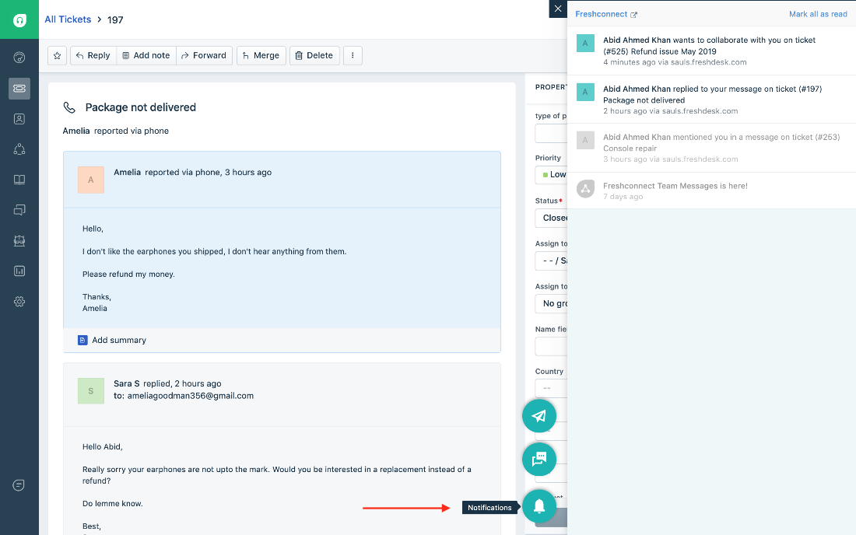

Figure 2 RRL: Freshdesk Interface Screenshot

The set of features introduced in this software focuses on helping the users maximize their worktime by utilizing the creation and organization of tickets such as the Team Inbox for tracking the incoming tickets from a multitude of channels, Agent Collision Detection to avoid having the different personnel work on the same ticket. They also include a self-service feature so that customers can solve their own problems without the need to contact a live person by using forums and articles. They also have a feature to organize the team’s tasks so that they can improve the efficiency of their work [6].

### 2.2.2 Spiceworks

*Spiceworks* is another IT helpdesk ticketing system that is free and is cloud-based [7].



Figure 3 RRL: Spiceworks Logo

The highlight of this software is that because it is cloud-based, it can support ticket organization and management even when an organization has branches in different areas or when they have remote employees.

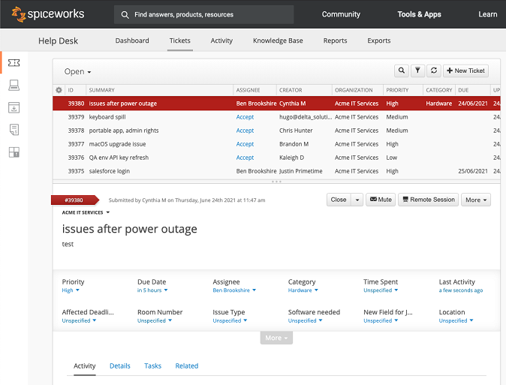

Figure 4 RRL: Spiceworks Interface

It has the ability of managing IT-support tickets by having the features such as the accepting, replying, and commenting on tickets, custom field tracking, self-service system, and integration with other software such as Power BI for business analytics. It also has features for team collaboration, and it includes help desk team management that monitors the performance of each organization members, ticket collaboration where other members can help one in need in solving a ticket, and a multi-site support that will cater all the organization members even in those who are in different areas and the ability to integrate it with the master or the center help desk.

### 2.2.3 LiveChat

LiveChat is an application that is dedicated for customer care and a tool for e-commerce [8].



Figure 5 RRL: LiveChat Logo

The highlight of this system are its widgets, small dashboard that includes chat, SMS and email. It also offers integration with common software platforms such as Salesforce, Facebook messenger, etc. It has share announcement, and a function to introduce new products via chat and caters personalized readings as it is mainly used for e-commerce [9].

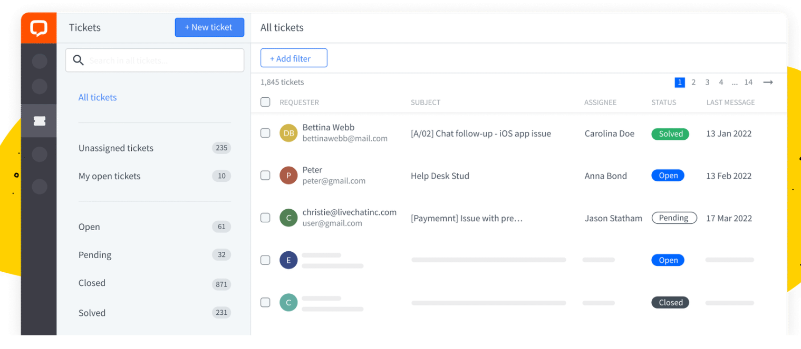

Figure 6 RRL: LiveChat Interface

### 2.2.4 Hiver

Hiver is a Software-as-a-Service application that collaborates with email for better customer support organization. It is also known that Hiver is used for Harvard University’s customer communication [10].



Figure 7 RRL: Hiver Logo

The highlight of this system includes streamlining incoming emails. It turns emails into actionable tasks and delegate them to the team members with just 2 clicks. Mark emails as Open, Pending, or Closed and always keep a tab on their status. It also makes internal team collaboration easier as it uses notes to collaborate with the team to respond to inquiries or solve issues that the staff and students may be facing without relying on email forwards, Ccs or external collaboration tools. Mentioning teammates is also a feature to notify them and have them respond to issues faster. It makes response faster with email templates because ITRO Administrative and IT teams in educational institutes usually spend a lot of time answering repetitive queries. This system creates email templates and use them right from the Gmail compose window for lightning-fast replies. Lastly, it puts an end to missed emails because of the creation of SLA (Service Level Agreement) rules that ensures a never miss responding to an email. When an SLA is violated, Hiver sends an instant notification to the team and attaches an SLA violation tag to the email. This SLA violation is also seen in the email activity feed.

### 2.2.5 LiveAgent

LiveAgent is a live chat software that improved to be an entire customer service platform [11]. This system is known to be utilized by the UEI College – Fresno [12].



Figure 8 RRL: LiveAgent Logo

Features includes chat specific analytics to get more insight into customer interactions, also creates proactive chat messages to make sure the staff get in front of people at the right time. eliminates account sharing, SLA and action triggered automation rules. It has fully customizable self-service and customer support with KB, Forums, and an integrated guide [13].

### 2.2.6 Zendesk

*Zendesk* is a software that is one of the most famous ticketing system software for customer support being this specific service as one of their core competencies. Because of their wide-range system, it is best used as a school help desk for large departments with big budgets [11]. Some schools that used this software includes (1) University of Louisville in Louisville, Kentucky (2) Ohio Wesleyan University in Delaware, Ohio (3) USC Annenberg School for Communication and Journalism, Los Angeles, CA and Beloit College, City in Wisconsin [14].



Figure 9 RRL: Zendesk Logo

Highlight features includes Customized views Live chat and messaging, automated routing, a knowledge-based software, community forums, and multi-language support.

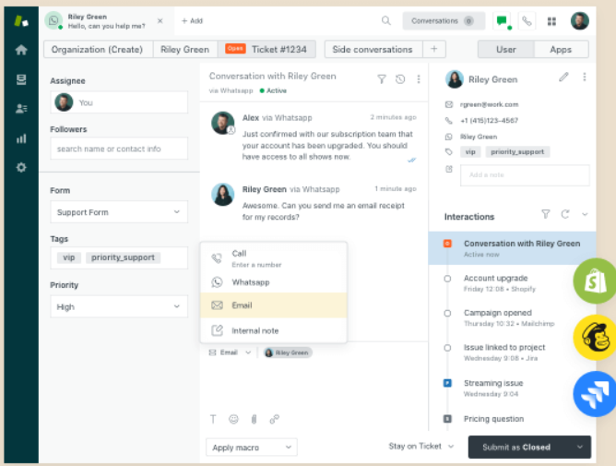

Figure 10 RRL: Zendesk Interface

### 2.2.7 Help Scout

Help Scout is a software that is dedicated for email management and is best used for student communication in an institution [11]. Some of the schools that utilized the features of this system are the University of Hawaii at Manoa in Honolulu, University of Oregon in Eugene, Oregon, and University of Amsterdam in Netherlands



Figure 11 RRL: Help Scout Logo

Some features that make the most of Help Scout are their shared inboxes wherein there is a private note and @mentions to make team collaboration a breeze, collision detection which reduces agent’s duplicate work, automated routine tasks like sorting and assigning incoming requests based on parameters and enables creation of powerful self-service resources like FAQ pages or a knowledge base with Docs [15].

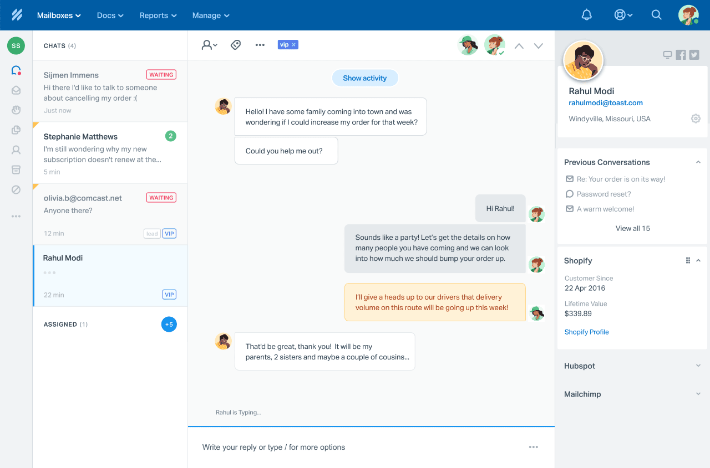

Figure 12 RRL: Help Scout Interface

### 2.2.8 SolarWinds

SolarWinds is a cloud-based application that is focused and utilized primarily by IT departments [16]. Their key features include checking and updating status and information of their tickets, replying to ticket with an email, notifying tech support of the tickets. They also have a Solutions database that caters resolution for known or common issues. They also provide a service catalog so that their customers are aware of the services they offer.



Figure 13 RRL: SolarWinds Logo

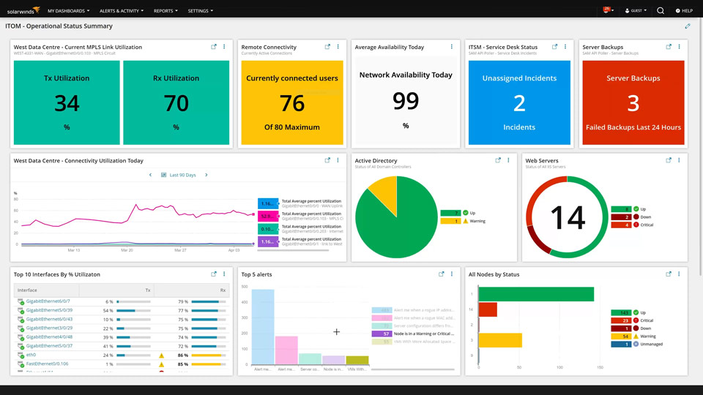

Figure 14 RRL: SolarWinds Interface

These systems (as seen in the figures above) can be a good reference in the team’s project proposal as it can help us see which process from the IT ticketing systems are overused, can be innovated further, and the gap that the team can provide a solution to.

The related system and literature included in this study have significant relationship with the future project in the sense that it can be deemed useful for the ITRO Client, students, teachers, as well as the school and the rest of its staff, which is of concern to the system being developed.

The ITRO, as the ITRO Client, would be able to maximize the use of their limited schedule by allowing the developers to see through these materials and improve the application, making them even more efficient.

The students and teachers on the other hand could read about these as well and find more ways as to how they could implement or suggest any other ways to improve the software to be developed for them to know how it works and how they could fully utilize it.

# Technical Background

## Current System

The current system being utilized is a dated, and ironically manual approach since the ITRO’s workflow and every other transaction revolve around the use of electronic messaging or emails.

### 3.1.1 MS Outlook

It is used by the current system as a platform for sending email requests to ITRO Admin, specifically to the head of the department which filters the request for approval.

### 3.1.2 Internet Connection

The current system also requires internet connection for the email requests to be sent by end user to the ITRO Admin.

## Proposed System

The team proposes the use and development of the project dubbed as RAMS Corner: An Intuitive Ticketing Service for ITRO Queries and Schedule Management in lieu of electronic mailing and traditional methods

### 3.2.1 Desktop Computer/ Mobile Phone

The proposed application is a reactive web-app that can be deployed in browsers of both mobile and desktop computers.

### 3.2.2 Internet Connection

The proposed system will also require internet connection for the raising and receiving requests on both the ITRO Admin and ITRO Client side.

# Methodology

## Requirements Analysis

### Product Backlog / User Stories

Table 1 Product Backlog/User Stories

|  |  |  |  |  |
| --- | --- | --- | --- | --- |
| ID | Title | **User Stories** | Acceptance Criteria | Priority |
| 1 | Assign Ticket | “As an ITRO Admin, I want to be able to have the requests automatically assigned to my staff so that I can maximize my time accommodating other requests” | Ability to assign tickets to ITRO staff | Could |
| 2 | Set Priority and Severity of a ticket | “As an ITRO Admin, ITRO Staff and ITRO Client, I want to be able to set the prioritization and urgency of the requests I receive so that I will know what requests need immediate resolution” | Ability to set and modify priority and severity level to a ticket | Must |
| 3 | Filter by Status | “As an ITRO Admin and ITRO Staff, I want to be able to filter the requests based on their status so that I will know what requests are near or far from its resolution” | Ability to filter tickets by the following status:   * Opened * Inspected * Pending * Ongoing * Resolved * Rejected * Cancelled | Must |
| 4 | Send automated ticket status | “As an ITRO Admin and ITRO Staff, I want to be able to have my ITRO Clients know what the status of their requests is so that my ITRO Clients can rest assured that we accommodate their requests.” | Ability of the system to send automated replies whenever there is a change in status | Must |
| 5 | View Knowledge Base | “As an ITRO Admin and ITRO Staffa, I want to be able to have a prepared list of common incidents and how to solve them so that I can minimize the percentage of redundant queries I receive | Ability to provide the resolution guidelines of resolved cases to the ITRO clients | Must |
| 6 | View ITRO-related Categories | “As an ITRO Client, I want to be able to see a categorized list of services that the ITRO offers so that I can know what the scope of the ITRO services that I can avail | Ability to view the exact list of the issues handled by the ITRO | Must |
| 7 | Self-Service Troubleshooting | “As an ITRO Client, I want to be able to See a help desk with listed common issues and their resolution so that I can save myself from sending an e-mail and wait for the resolution from the office” | Ability to do self-troubleshooting using the Knowledge Base containing all the resolution for the cases resolved. | Must |
| 8 | Status updates | “As an ITRO Client, I want to be able to view the status of my request so that I can keep track of the status of my ticket” | Ability to view current status and status history | Must |
| 9 | Generating Reports | “As an ITRO Admin, I want to be able to view how many requests the office receives so that I can keep track on how many requests the office serves at a specific amount of time and do workflow revisions based on it.” | Ability to generate the following reports by status (Opened, Inspected, Pending, Ongoing, Resolved, Rejected):   * Daily report * Weekly report * Monthly report * Annual report | Should |
| 10 | Staff Report | “As an ITRO Admin, I want to be able to view how many resolved requests there are so that I can see the result of our department’s hard work | Ability to view analytics report regarding the workload of the staff | Should |
| 11 | Create Ticket | “As an ITRO Client, I want to be able to send a personalized request so that I can further explain the issue that I want to raise” | Ability to create a ticket | Must |
| 12 | CC Field | “As an ITRO Client, I want to be able to tag a related persona to my request so that they would have notified them of my queries as well” | Ability to notify related persona in a ticket using the CC field in creating ticket | Must |
| 13 | View All Tickets | “As an ITRO Client, I want to be able to view all the tickets I have sent so that I can keep track of the cases I raised to the office” | Ability to view all the tickets sent | Must |
| 14 | Ticket Spamming | “As an ITRO Admin, I want to be able to limit our ITRO Client from sending redundant requests so that the office can prevent receiving spam and repeated cases” | Ability to limit the ITRO client from sending same case within the day | Could |
| 15 | Notification | “As an ITRO Admin, I want to be able to see a notification of the requests sent to the office so that I will be able to keep track of the incoming requests" | Ability of the system to notify the ITRO Admin whenever there is a new ticket | Must |
| 16 | Modify Notification | “As an ITRO Client, I want to be able to filter the notification I received so that I would not be annoyed of receiving a lot of notification” | Ability to filter notification base on some criteria | Could |

### Event Tables

Table 2 Event Tables

|  |  |  |  |  |  |
| --- | --- | --- | --- | --- | --- |
| **Event** | **Trigger** | **Source** | **Use case** | **Response** | **Destination** |
| 1. ITRO Admin, ITRO Staff, ITRO Client views a ticket | View Ticket | ITRO Admin  ITRO Staff ITRO Client | Display ticket | Show ticket details | ITRO Admin ITRO Staff ITRO Client |
| 1. ITRO Admin, ITRO Staff receives ticket | Receive Tickets | ITRO Admin ITRO Staff | Receive Ticket | Received Ticket Details | ITRO Admin ITRO Staff |
| 1. ITRO Admin, ITRO Staff, ITRO Client updates a ticket | Update Ticket | ITRO Admin ITRO Staff  ITRO Client | Updates Ticket | Updated Ticket Details | ITRO Client  ITRO Admin ITRO Staff |
| 1. ITRO Admin assigns a ticket | Assign Tickets | ITRO Admin | Assign Ticket | Assigned Ticket Contents | ITRO Admin  ITRO Staff |
| 1. ITRO Client creates a ticket about hardware/ software inquiry/ incident | ITRO Client Hardware/ Software Inquiry/ Incident | ITRO Client | Create Ticket | Ticket Details | ITRO Admin  ITRO Staff  ITRO Client |
| 1. ITRO Client, ITRO Staff searches KB for hardware/ software self-service troubleshooting | Search KB for hardware/software self-service troubleshooting | ITRO Client  ITRO Staff | Troubleshoot Hardware/ Software Concerns | Hardware and Software Trouble-shooting contents | ITRO Client  ITRO Staff |
| 1. ITRO Admin, ITRO Staff generates a dashboard report | Generate Dashboard Reports | ITRO Admin ITRO Staff | Produce Dashboard Reports | Dashboard  Reports | ITRO Admin  ITRO Staff |

### Use Case Diagrams

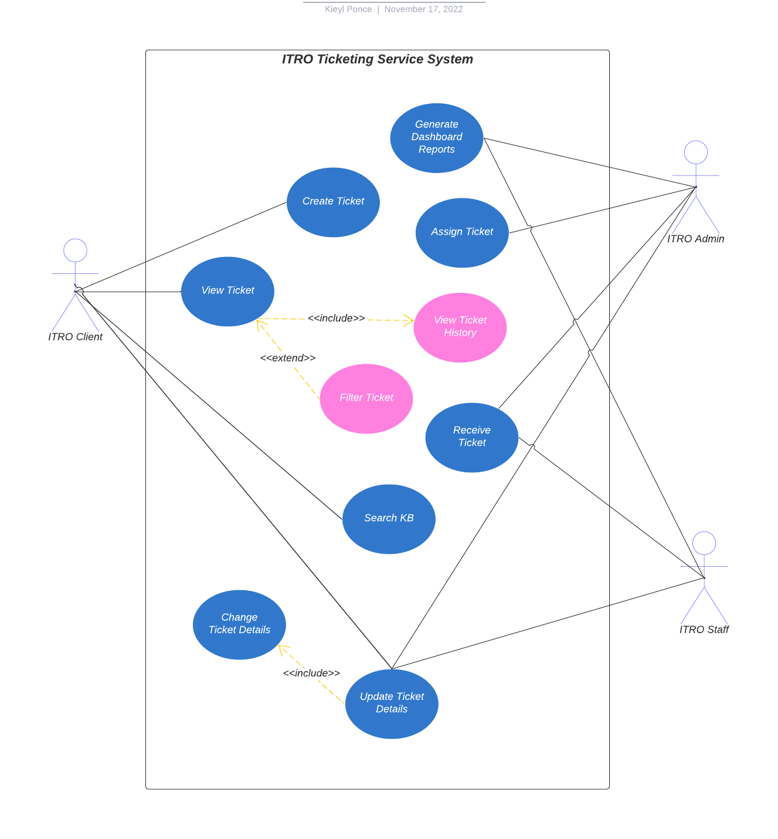

Figure 15 Use Case Diagram

### Use Case Full Description

Table 3 Use Case Full Description (1)

|  |  |  |
| --- | --- | --- |
| **Use Case Name:** | View Ticket | |
| **Scenario:** | ITRO Admin, ITRO Staff and ITRO Client views a ticket | |
| **Triggering Event:** | User chooses to press or execute “view ticket” command in the ITRO Ticketing System Application | |
| **Brief Description:** | The system would prompt the user of all of the relative information regarding a ticket received along with its current status. | |
| **Actors:** | Primary:  ITRO Admin  ITRO Staff  Secondary:  ITRO Client | |
| **Related Use Cases:** | Receive Ticket  Update Ticket  Assign Ticket | |
| **Stakeholders:** | * ITRO * APC Students * APC Faculty/Staff | |
| **Preconditions:** | User should already have an account registered to prove his/her association with the APC-ITRO or the school itself (Asia Pacific College) as a student or a faculty member. | |
| **Postconditions:** | The ITRO Staff/ITRO Admin would be able to see all of the received tickets along with its details. | |
| **Flow of Activities:** | **Actor** | **System** |
| 1. User Login 2. View Tickets   3. Select ticket  4. view selected ticket information | * 1. verify user credentials   2. prompt homepage selection screen   3. gather available data   4. display tickets list   3.1 retrieve selected ticket data  3.2 display ticket data |
| **Exception Conditions** | * Network Unavailable * Server Down * Invalid User Credentials | |

Table 4 Use Case Full Description (2)

|  |  |  |
| --- | --- | --- |
| **Use Case Name:** | Generate Dashboard Reports | |
| **Scenario:** | ITRO Admin or Staff wants produce dashboard reports | |
| **Triggering Event:** | User chooses to press or execute “Generate Dashboard Reports” command in the ITRO Ticketing System Application | |
| **Brief Description:** | The system would prompt the user of all of the relative information regarding the number of tickets received, handled, and solved by the APC-ITRO within a day, a week, a month, or a year. | |
| **Actors:** | Primary:  ITRO Admin  ITRO Staff  Secondary:  ITRO Client | |
| **Related Use Cases:** | Receive Ticket  Update Ticket  Assign Ticket | |
| **Stakeholders:** | * ITRO * APC Students * APC Faculty/Staff | |
| **Preconditions:** | * User should already have an account registered to prove his/her association with the APC-ITRO. * User must either be a staff or an ITRO Admin of the APC-ITRO to be able to execute this command. | |
| **Postconditions:** | The ITRO Staff/ITRO Admin would be able to see a printable breakdown of all the necessary information regarding the number of tickets received, handled, and solved by the APC-ITRO within the selected timespan | |
| **Flow of Activities:** | **Actor** | **System** |
| 1. User login 2. Select “Generate Dashboard Report” 3. view dashboard reports. | * 1. verify user credentials   2. prompt homepage selection screen   3. gather necessary data   4. display daily reports   5. prompt optional weekly or annual reports |
| **Exception Conditions** | * No Tickets Received * Network Unavailable * Server Down * Invalid User Credentials | |

Table 5 Use Case Full Description (3)

|  |  |  |
| --- | --- | --- |
| **Use Case Name:** | Assign Ticket | |
| **Scenario:** | ITRO Admin assigns a ticket to a staff | |
| **Triggering Event:** | User chooses to press or execute the “Assign Ticket” command—exclusive to the ITRO Admin. | |
| **Brief Description:** | The system would prompt the user of all of the relative information regarding the unassigned of tickets | |
| **Actors:** | Primary:  ITRO Admin  Secondary:  ITRO Staff  ITRO Client | |
| **Related Use Cases:** | Receive Ticket  Update Ticket  Produce Dashboard Reports | |
| **Stakeholders:** | * ITRO * APC Students * APC Faculty/Staff | |
| **Preconditions:** | * User must have ITRO Admin privileges * A ticket from a ITRO Client must be received * User should already have an account registered to prove his/her association with the APC-ITRO. | |
| **Postconditions:** | An ITRO staff would receive a notification regarding his/her ticket assignment designated by the ITRO Admin. | |
| **Flow of Activities:** | **Actor** | **System** |
| 1. User Login 2. View Tickets 3. Select ticket 4. assign ticket 5. select desired ITRO Staff | * 1. verify user credentials   2. prompt homepage selection screen   3. gather available data   4. display tickets list   3.1 retrieve selected ticket data  3.2 display ticket data  3.3 prompt “update ticket” option  3.4 prompt “assign ticket” option (ITRO Admin-only)  4.1 gather ITRO staff credentials’ information  4.2 display available ITRO staff suited for the assignment |
| **Exception Conditions** | * No Tickets Received * No Available Staff * Network Unavailable * Server Down * Invalid User Credentials | |

Table 6 Use Case Full Description (4)

|  |  |  |
| --- | --- | --- |
| **Use Case Name:** | Create Ticket | |
| **Scenario:** | Client to creates a ticket | |
| **Triggering Event:** | User chooses “create ticket” command in the application | |
| **Brief Description:** | The system would prompt the user with an empty ticket to be filled to specify his/her software/hardware concerns—granted that it is not included in the KB section of the application. | |
| **Actors:** | Primary:  ITRO Client    Secondary:  ITRO Admin  ITRO Staff | |
| **Related Use Cases:** | Receive Ticket  Update Ticket  View Ticket  Assign Ticket  Produce Dashboard Reports | |
| **Stakeholders:** | * ITRO * APC Students * APC Faculty/Staff | |
| **Preconditions:** | * User should already have an account registered to prove his/her association with the APC-ITRO or the school itself (Asia Pacific College) as a student or a faculty member. * User query should be unique and not be listed on the KB section of the ITRO. | |
| **Postconditions:** | A notification would be received after a ticket has been successfully sent. | |
| **Flow of Activities:** | **Actor** | **System** |
| 1. User login          1. Select “Create Ticket”             3. Provide Necessary Details | 1. verify user credentials 2. prompt homepage selection screen     2.1 prompt blank ticket  2.2 toggles query type (hardware/software)  2.3 ask date, time, and an option to tag a related persona    3.1 compile provided data  3.2 examine provided data  3.3 save provided data |
| **Exception Conditions** | * Invalidated Ticket * Invalid Request (Outside of ITRO’s field of expertise) * Network Unavailable * Server Down * Invalid User Credentials | |

Table 7 Use Case Full Description (5)

|  |  |  |
| --- | --- | --- |
| **Use Case Name:** | View KB | |
| **Scenario:** | View KB for hardware/software self-service troubleshooting | |
| **Triggering Event:** | User chooses to press or execute the “View KB” command in the application | |
| **Brief Description:** | The system would prompt the user of all of the relative information regarding the most commonly known incidents regarding software and hardware issues for effective self-troubleshooting. | |
| **Actors:** | Primary:  ITRO Client  Secondary:  ITRO Admin  ITRO Staff | |
| **Related Use Cases:** | Create Ticket  Update Ticket | |
| **Stakeholders:** | * ITRO * APC Students * APC Faculty/Staff | |
| **Preconditions:** | * User should already have an account registered to prove his/her association with the APC-ITRO or the school itself (Asia Pacific College) as a student or a faculty member. | |
| **Postconditions:** | The system would prompt the user of all of the relative information regarding the most commonly known incidents regarding software and hardware issues for effective self-troubleshooting. | |
| **Flow of Activities:** | **Actor** | **System** |
| 1. User login 2. Select “Self-Service Troubleshooting” 3. Select Option for Query 4. Commence self-troubleshooting/self-learning | * 1. verify user credentials   2. prompt homepage selection screen   2.1 Prompt Hardware and Software options   * 1. retrieve necessary data   2. display related information for the chosen problem aspect |
| **Exception Conditions** | * Network Unavailable * Server Down * Invalid User Credentials | |

Table 8 Use Case Full Description (6)

|  |  |  |
| --- | --- | --- |
| **Use Case Name:** | Receive Ticket | |
| **Scenario:** | ITRO Admin/ITRO Staff receives a ticket | |
| **Triggering Event:** | A ITRO Client would create a ticket and send it to the ITRO | |
| **Brief Description:** | The system would notify the ITRO Admin and ITRO Staff regarding the newly received ticket | |
| **Actors:** | Primary:  ITRO Admin  ITRO Staff  Secondary:  ITRO Client | |
| **Related Use Cases:** | Create Ticket  Update Ticket  Produce Dashboard Reports | |
| **Stakeholders:** | * ITRO * APC Students * APC Faculty/Staff | |
| **Preconditions:** | * A ITRO Client must be able to successfully send a ticket to trigger this feature. * User should already have an account registered to prove his/her association with the APC-ITRO. * User must either be a staff or an ITRO Admin of the APC-ITRO to be able to use this feature. | |
| **Postconditions:** | The system would notify the user upon the arrival of a new ticket from a ITRO Client. | |
| **Flow of Activities:** | **Actor** | **System** |
| 1. User login 2. Select ticket 3. Examine Received ticket | * 1. verify user credentials   2. prompt homepage selection screen   3. notify user upon ticket arrival   4. prompt a pop-up to view ticket   2.1 retrieve ticket data  2.2 Display ticket information |
| **Exception Conditions** | * Network Unavailable * Server Down * Invalid User Credentials | |

Table 9 Use Case Full Description (7)

|  |  |  |
| --- | --- | --- |
| **Use Case Name:** | Update Ticket | |
| **Scenario:** | ITRO Admin/ITRO Staff wants to update a ticket | |
| **Triggering Event:** | A ticket being processed has a new development | |
| **Brief Description:** | Upon ticket receipt and progression, the ITRO Staff/ITRO Admin can update the status of an ongoing ticket to notify the sender about its status, especially if the said ticket is a subject to an exception in need of a special course of action depending on the verdict of the ITRO staff or the ITRO Admin | |
| **Actors:** | Primary:  ITRO Admin  ITRO Staff  ITRO Client | |
| **Related Use Cases:** | Create Ticket  Receive Ticket  Produce Dashboard Reports | |
| **Stakeholders:** | * ITRO * APC Students * APC Faculty/Staff | |
| **Preconditions:** | * A ITRO Client must be able to successfully send a ticket to the ITRO to trigger this feature. * A ticket must be assigned to a staff to record its progression * User should already have an account registered to prove his/her association with the APC-ITRO. * User must either be a staff or an ITRO Admin of the APC-ITRO to be able to use this feature. | |
| **Postconditions:** | The system would notify the sender of the ticket about its status (with a possible personal note) as intended by the assigned ITRO Staff. | |
| **Flow of Activities:** | **Actor** | **System** |
| 1. User Login 2. View Tickets   3. Select ticket  4. update ticket  5. select new ticket status | * 1. verify user credentials   2. prompt homepage selection screen   3. gather available data   4. display tickets list   3.1 retrieve selected ticket data  3.2 display ticket data  3.3 prompt “update ticket” option  4.1 prompt ticket status modification  4.2 ask optional personalized message  5.1 update and save new ticket information  5.2 notify ticket sender about new ticket status |
| **Exception Conditions** | * No Progress Made * Network Unavailable * Server Down * Invalid User Credentials | |

## System Analysis and Design

### 4.2.1 Context Diagram

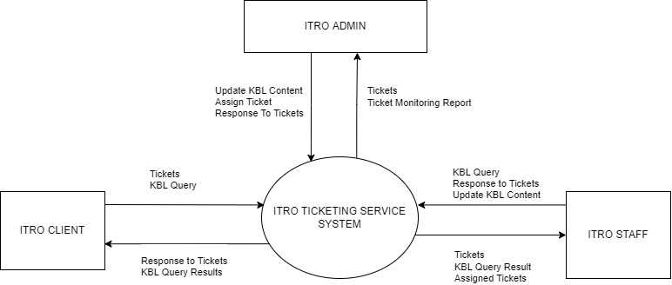

Figure 16 Context Diagram

### 4.2.2 Data Flow Diagrams

### 

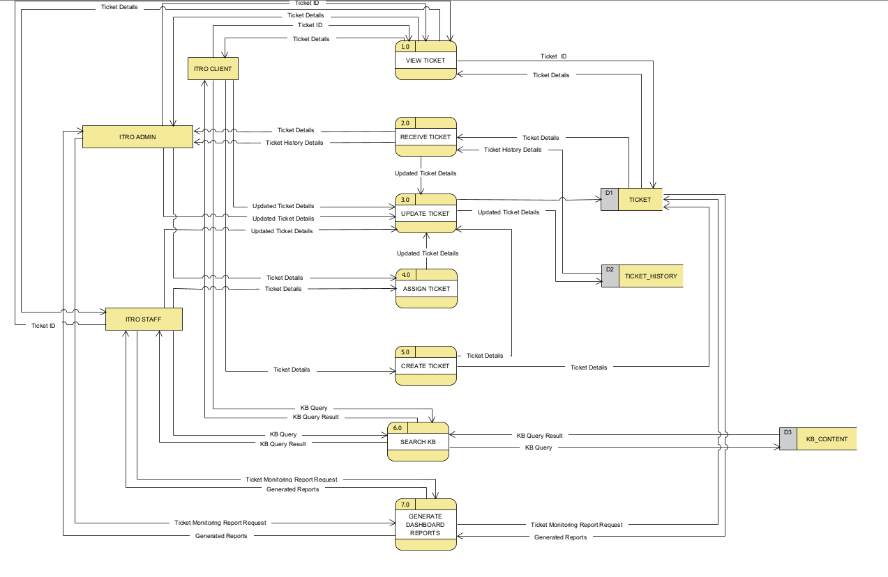

Figure 17 Level 0 DFD

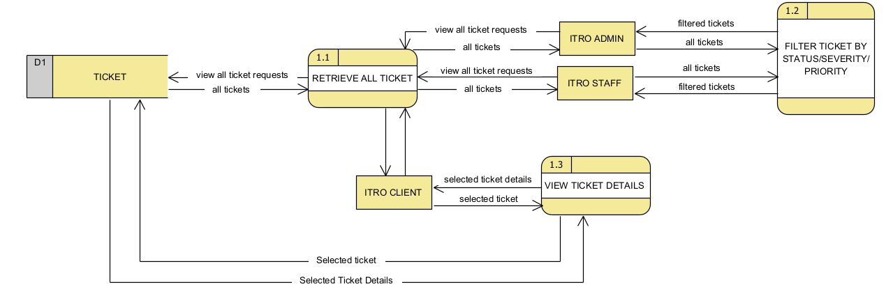

Figure 18 Level 1 DFD: Process 1

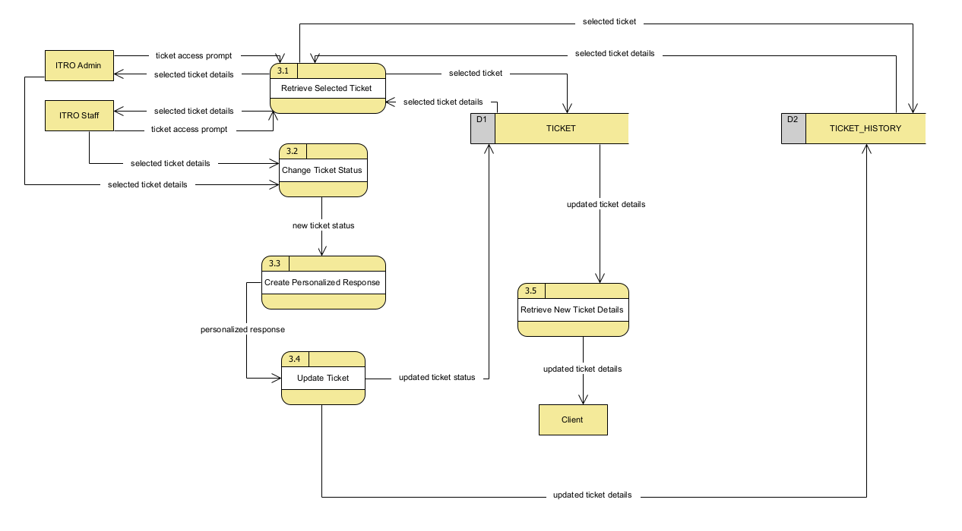

Figure 19 Level 1 DFD: Process 3

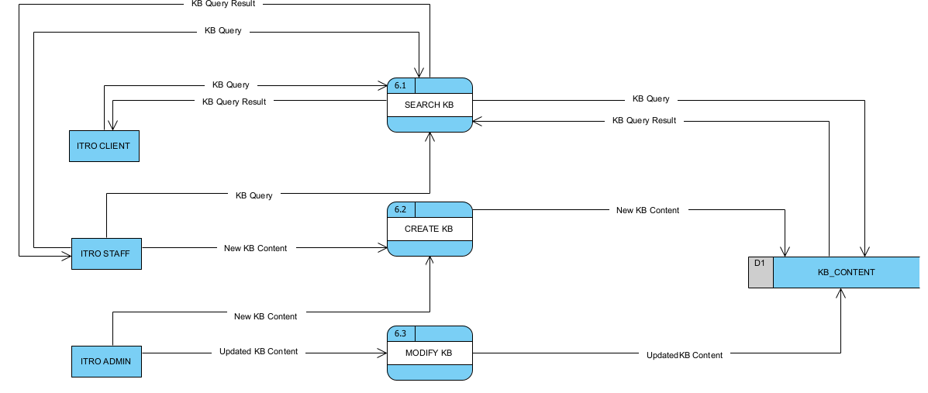

Figure 20 Level 1 DFD: Process 6

### 4.2.3 Entity-Relationship Diagrams

<https://app.diagrams.net/#G1YKv75ooMsHiowluOz6-chseEl5IbyeG9>

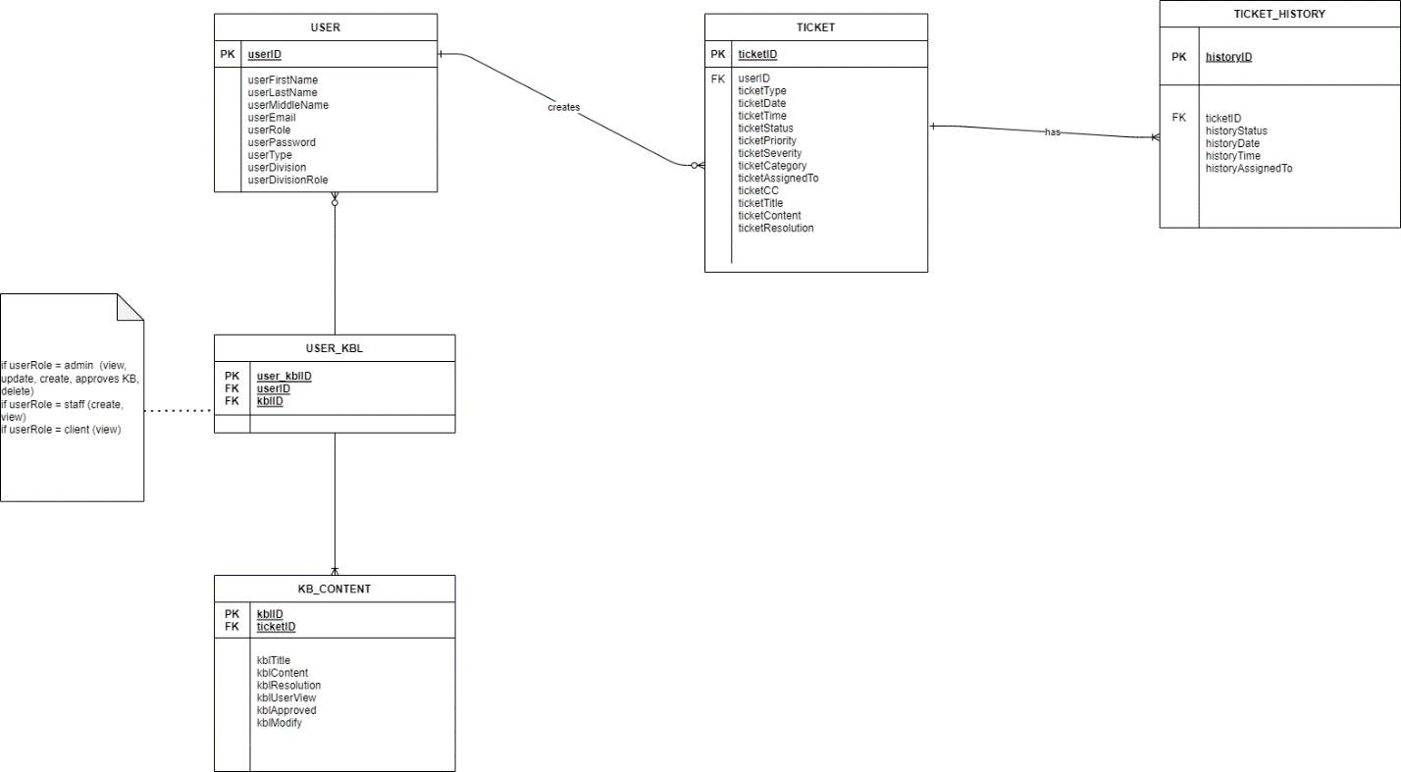

Figure 21 Entity Relationship Diagram

### 4.2.4 Activity Diagrams

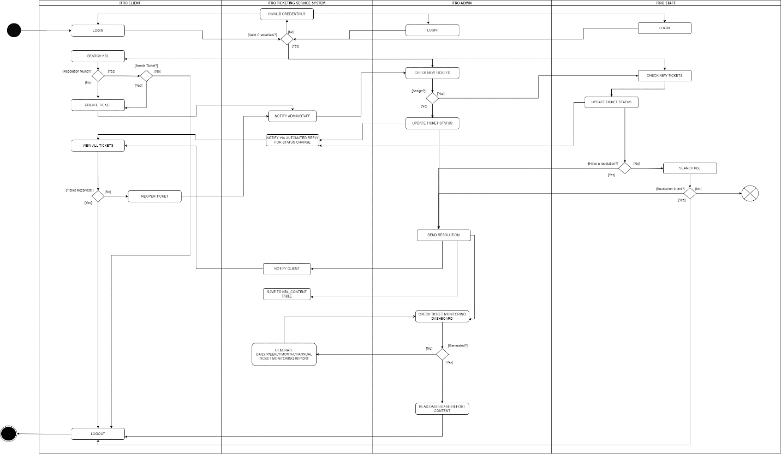

Figure 22 Activity Diagram

### 4.2.5 Object Diagrams

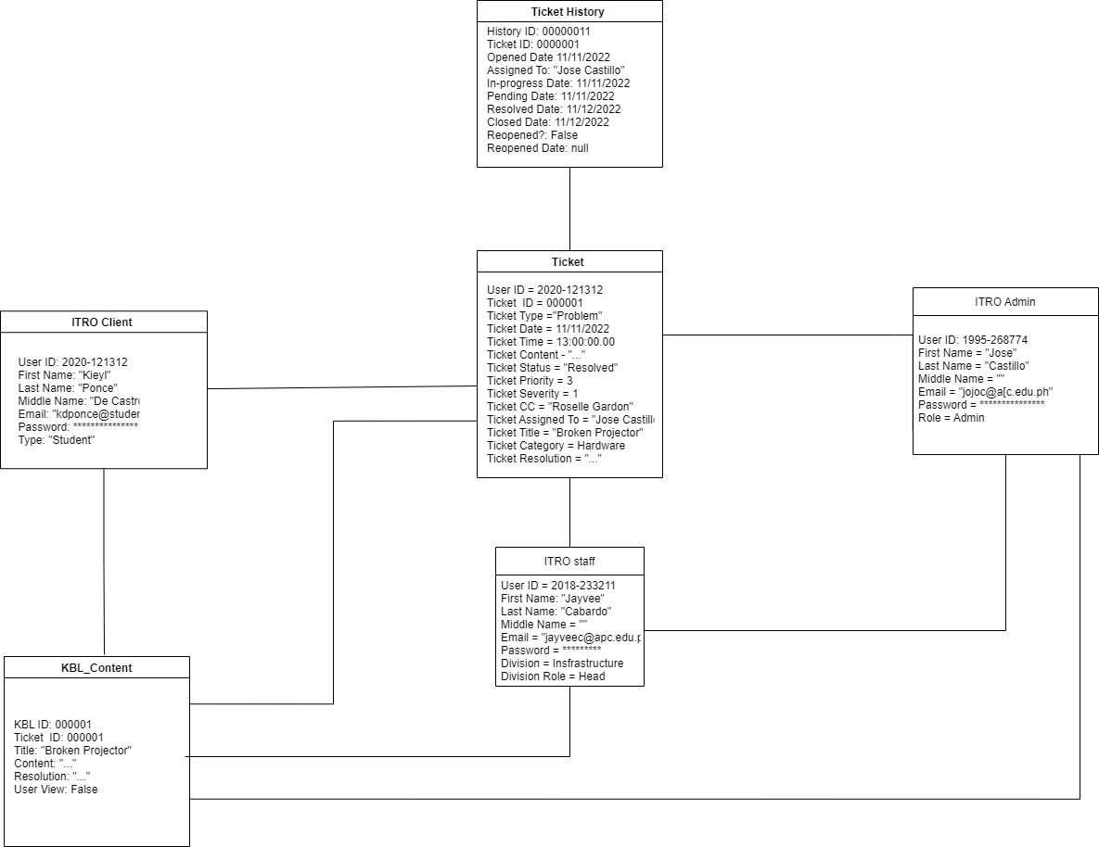

Figure 23 Object Diagram

### 4.2.6 Class Diagrams

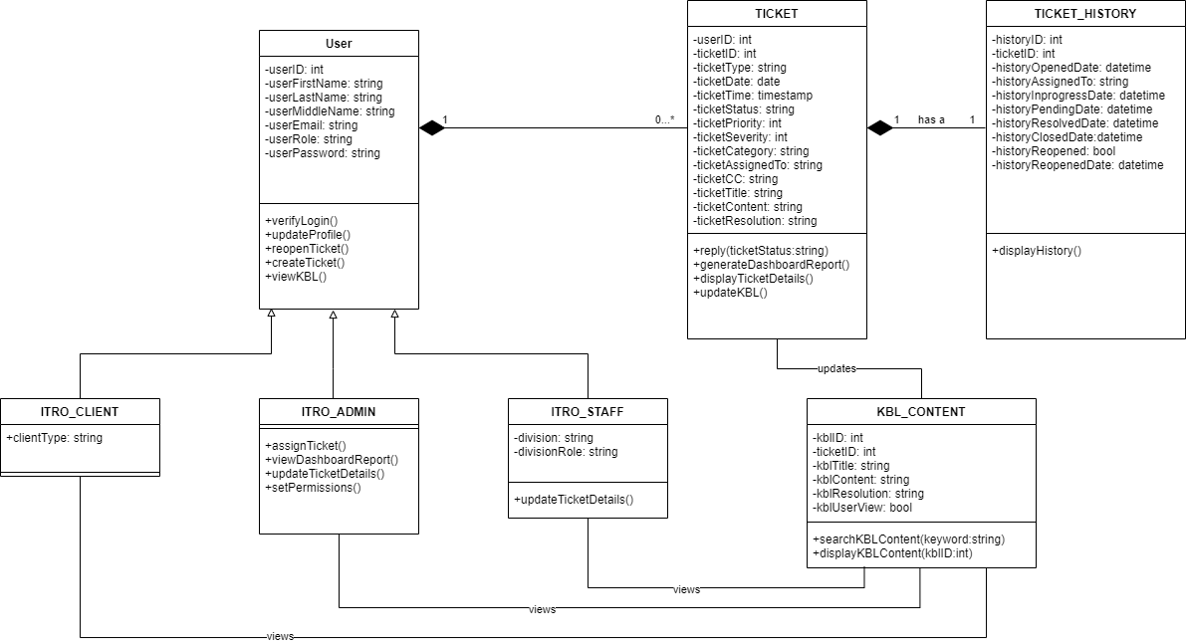

Figure 24 Class Diagram

### 4.3.7 Sequence Diagram

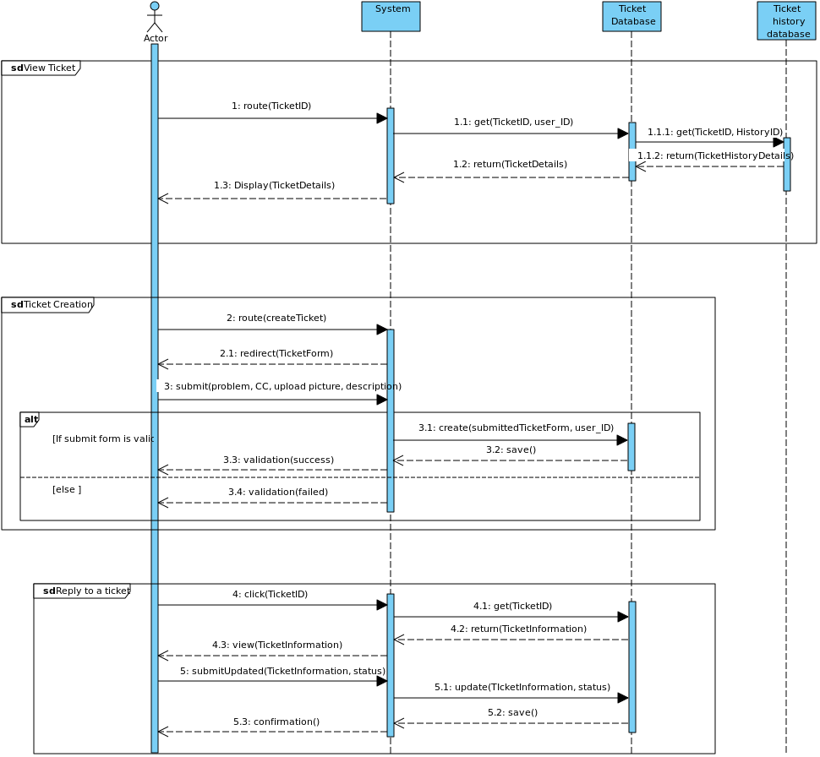

Figure 25 Sequence Diagram

### 4.2.8 State Transition Diagram

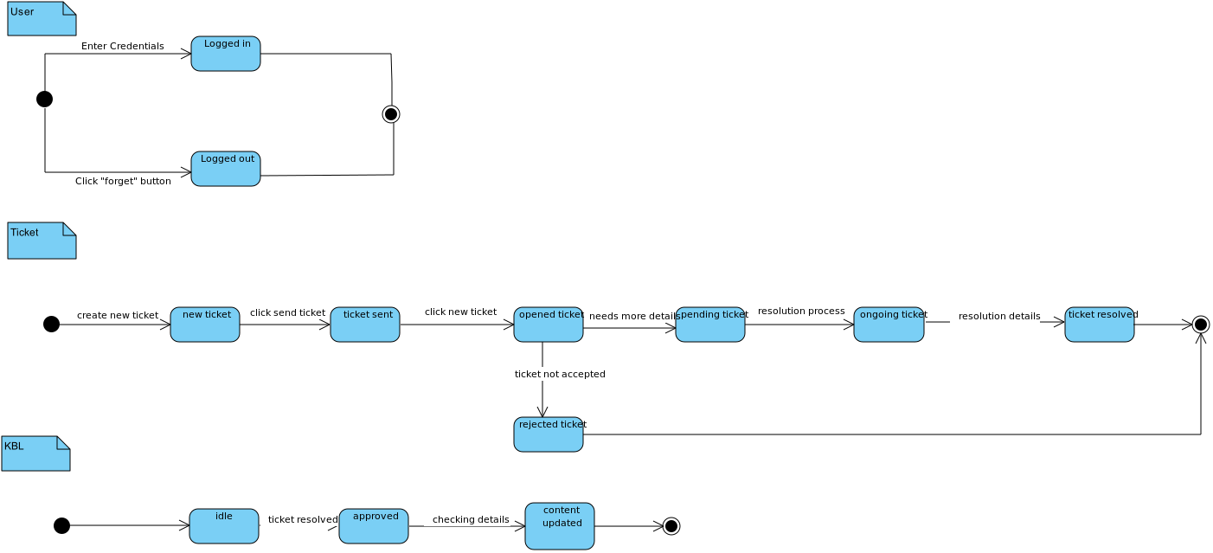

Figure 26 State Transition Diagram

### 4.2.9 Package Diagram

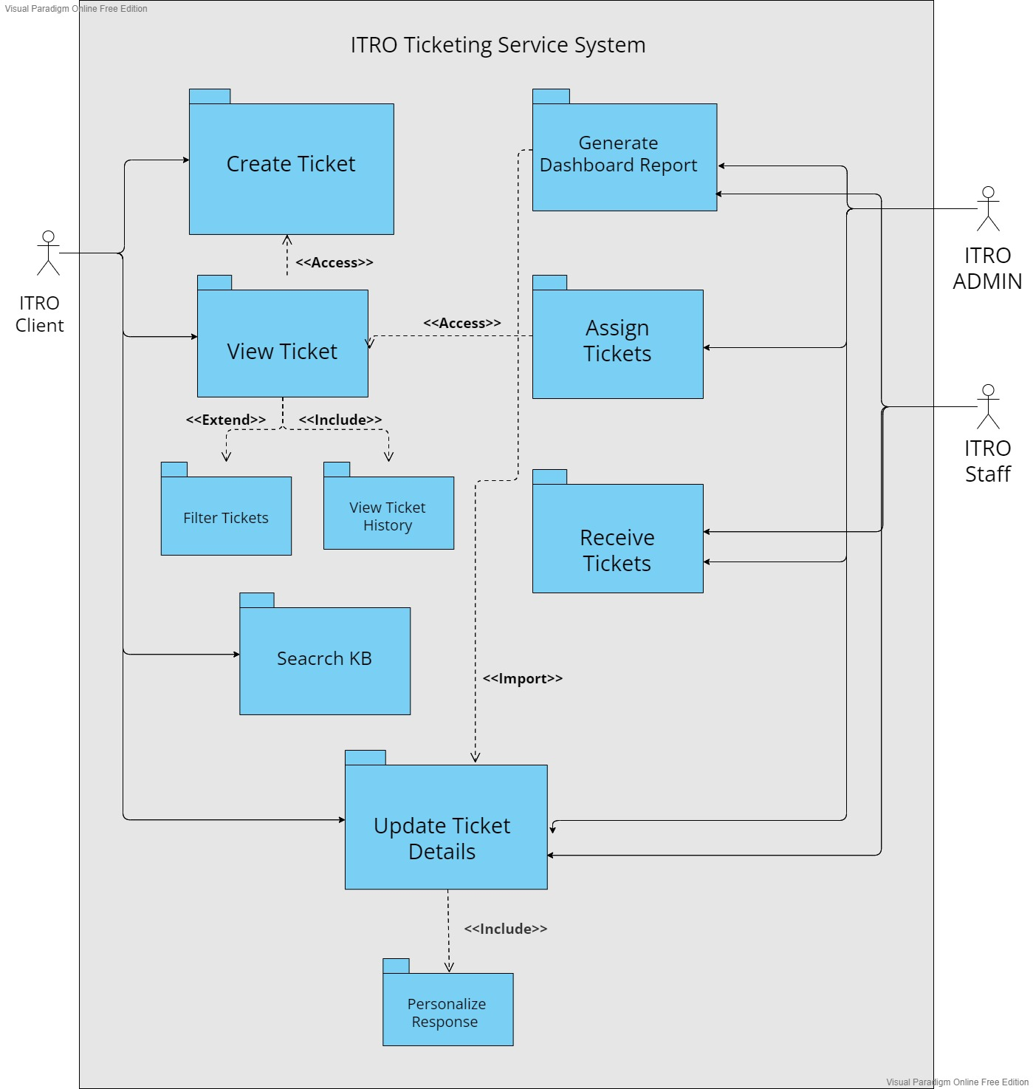

Figure 27 Package Diagram

### 4.2.10 Component Diagram

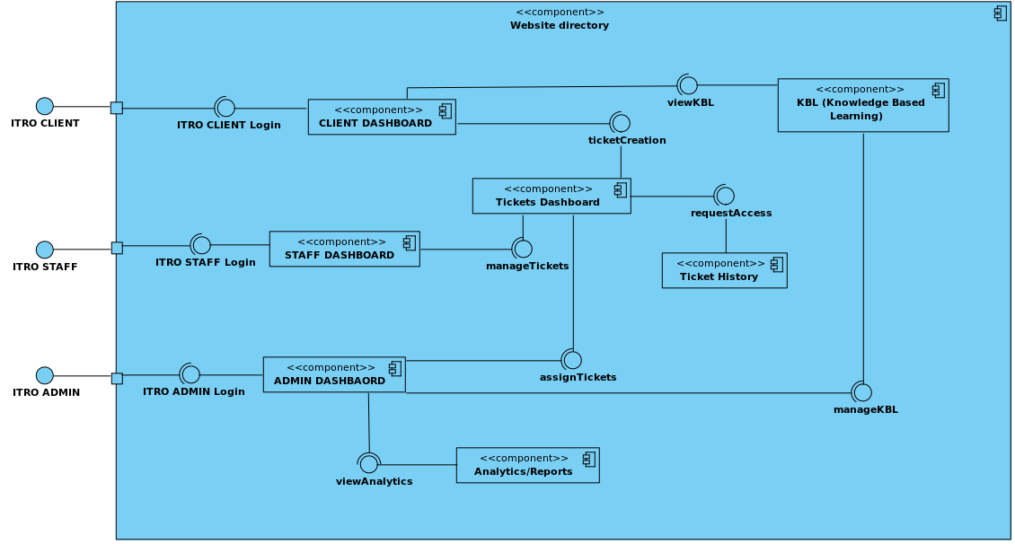

Figure 28 Component Diagram

### 4.2.11 Deployment Diagram

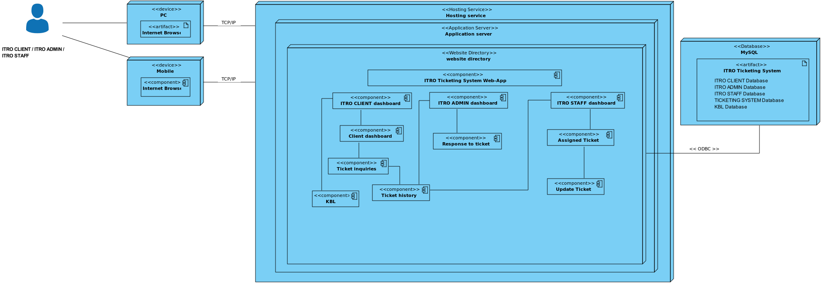

Figure 29 Deployment Diagram

# Results and Discussion

## 5.1 Release Plan

***Release 1***

* ITRO Ticketing Service System UI/UX Design

***Release 2***

* ITRO ADMIN and ITRO STAFF can open the web application using any browser
* ITRO ADMIN and ITRO STAFF can log in on the application
* ITRO ADMIN and ITRO STAFF can be notified of the incoming tickets
* ITRO ADMIN can manually assign tasks to the staff member
* ITRO ADMIN, ITRO STAFF, and ITRO CLIENT can set the priority level of the ticket
* ITRO ADMIN, and ITRO STAFF can filter the tickets received by their status and prioritization
* ITRO ADMIN and ITRO STAFF can reply to the tickets sent by the ITRO CLIENT
* ITRO ADMIN and ITRO STAFF can monitor the tasks assigned per ITRO Staff member
* ITRO ADMIN and ITRO STAFF can generate a softcopy of the report using the analytics/insights
* ITRO CLIENT can open the web application using any browser
* ITRO CLIENT can log in in the application
* ITRO CLIENT can add the web application on the home screen of their phones
* ITRO CLIENT can raise a ticket to the office
* ITRO CLIENT can tag a teacher on the Cc Field
* ITRO CLIENT can view all the tickets they raised
* ITRO CLIENT can filter the tickets they raised based on their prioritization and status
* ITRO CLIENT can access the KB Section for incidents that they can solve by themselves

***Release 3***

* ITRO ADMIN and ITRO STAFF can set a limit of the same request made by one user to avoid ticket-spamming
* ITRO ADMIN and ITRO STAFF can view the progress of the ticket, whether it is pending, inspected, ongoing, or resolved
* ITRO ADMIN and ITRO STAFF can view how many tickets are received per time-basis (daily, weekly, monthly)
* ITRO ADMIN and ITRO STAFF can view how many tickets are resolved per time-basis (daily, weekly, monthly)
* ITRO ADMIN and ITRO STAFF can view how many tickets are not resolved per time-basis (daily, weekly, monthly)
* ITRO ADMIN and ITRO STAFF can view how many tickets are pending per time-basis (daily, weekly, monthly)
* ITRO ADMIN and ITRO STAFF can view how many tickets are still ongoing or fixing per time-basis (daily, weekly, monthly)
* ITRO ADMIN and ITRO STAFF can send an update and have an automated reply after of the status of the user’s ticket
* ITRO CLIENT can select between the two tags with ITRO Scope
* ITRO CLIENT can choose a category of which their issue is about
* ITRO CLIENT can filter the notification they receive by their status
* ITRO CLIENT can attach an image to their tickets
* ITRO CLIENT can view the progression of their ticket, whether it is set pending, inspected, ongoing, or resolved

## 5.2 Prototype

#### 4.3.4.1 Web View

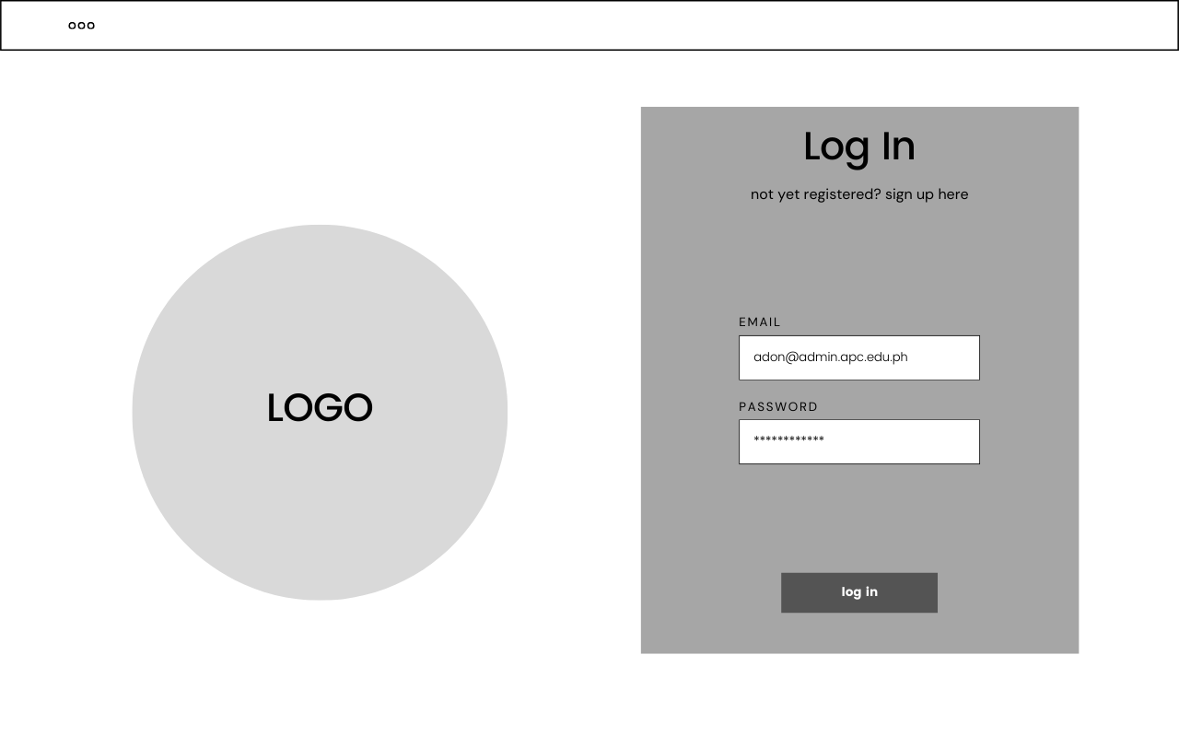

Figure 30 Web View - All User Login

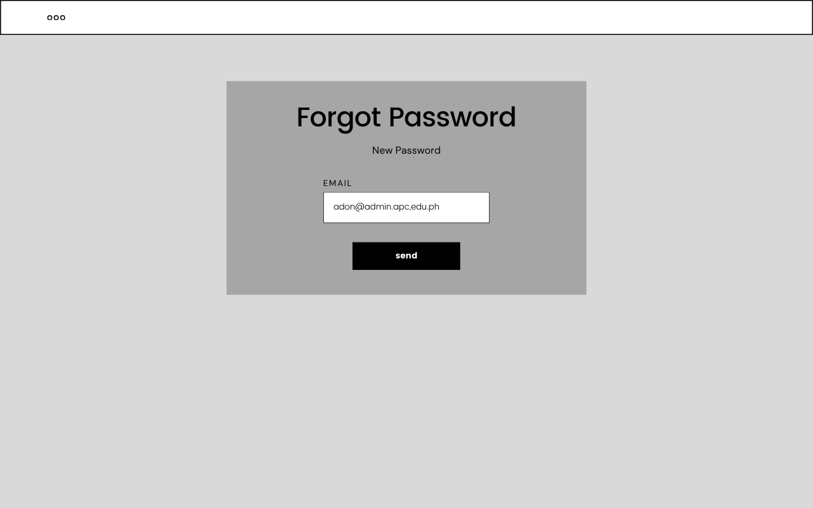

Figure 31 Web View - All User Forgot Password

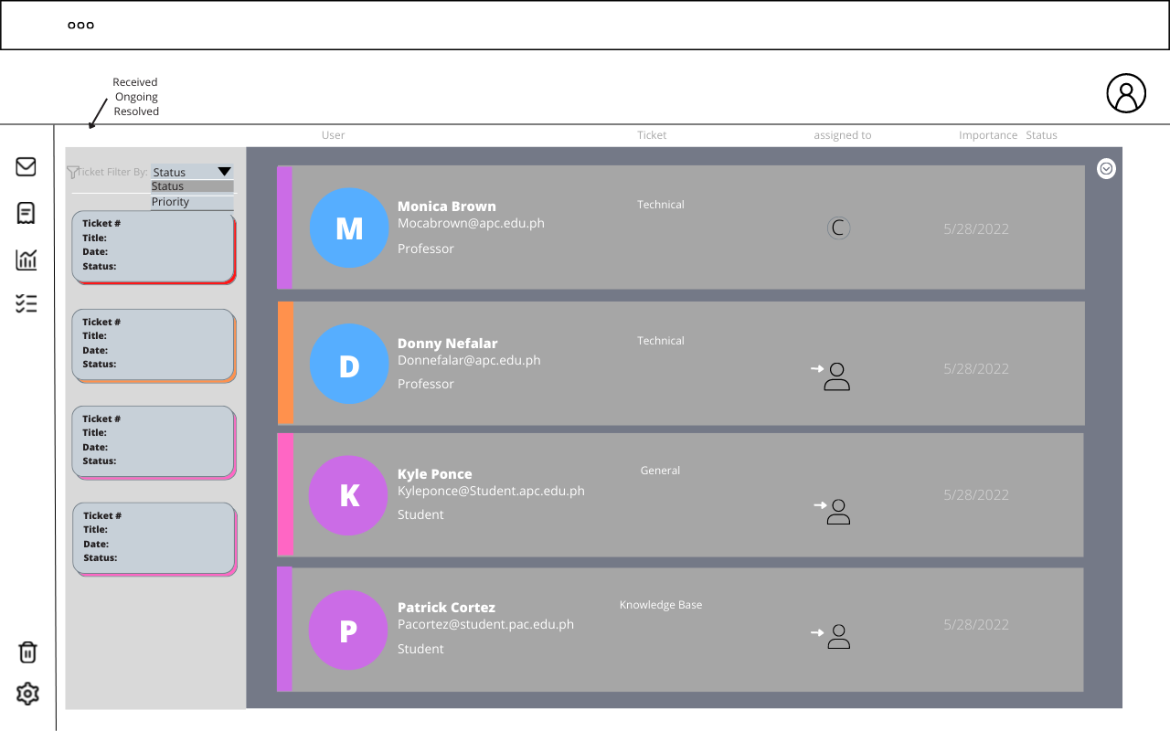

Figure 32 Web View - All Users View All Tickets

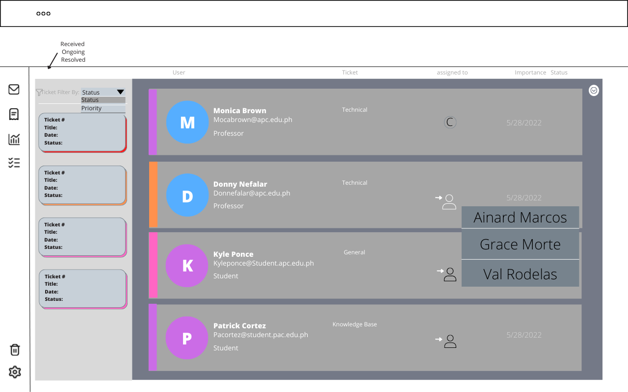

Figure 33 Web View - ITRO Admin Assign Tickets

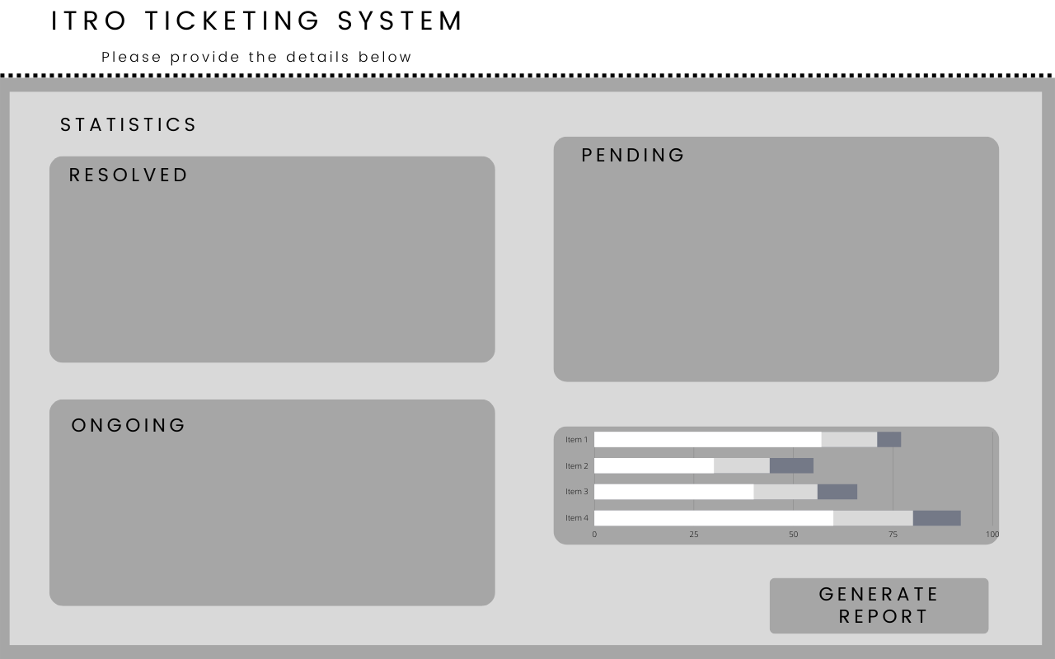

Figure 34 Web View - ITRO Admin Dashboard

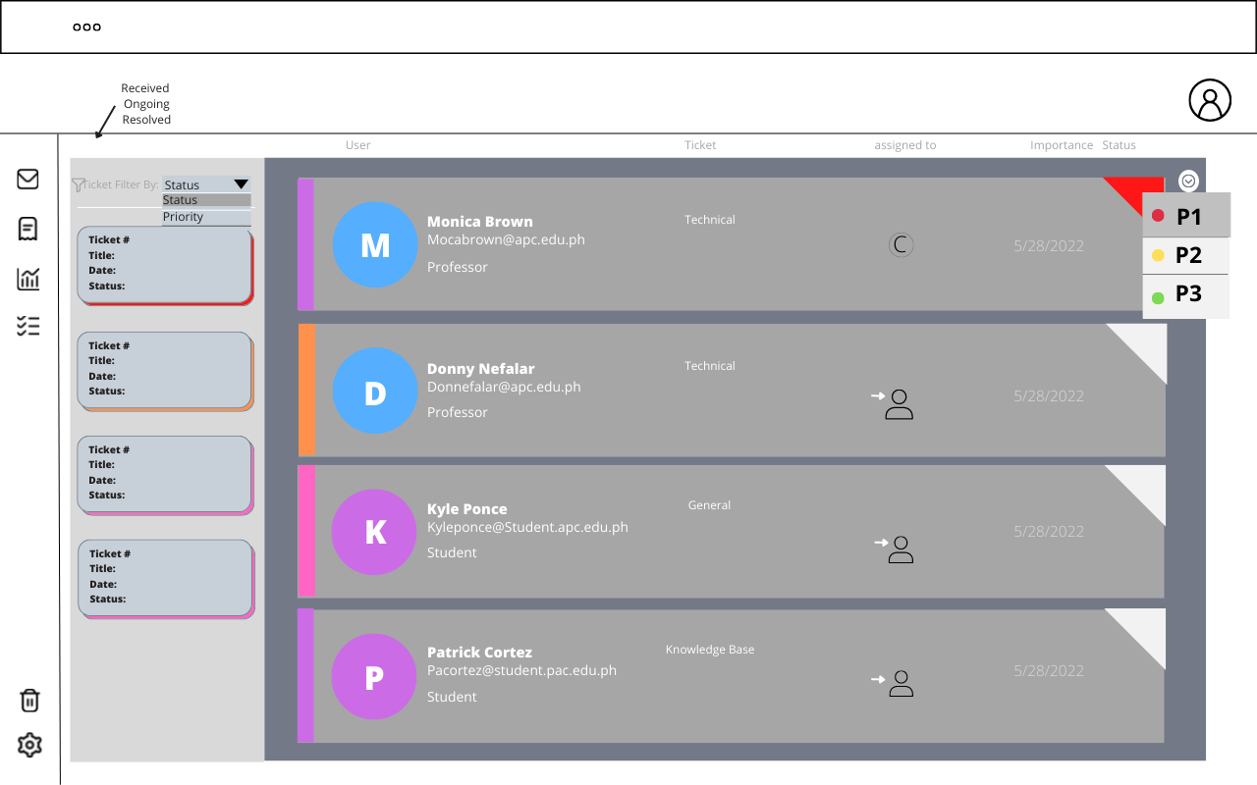

Figure 35 Web View - ITRO Admin Assign Ticket Priority Level

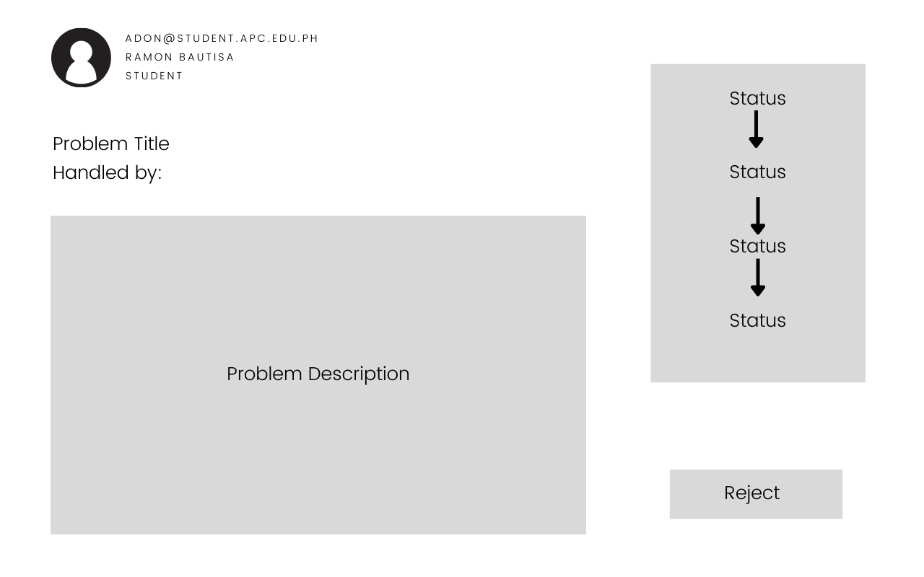

Figure 36 Web View - ITRO Admin Open Ticket View

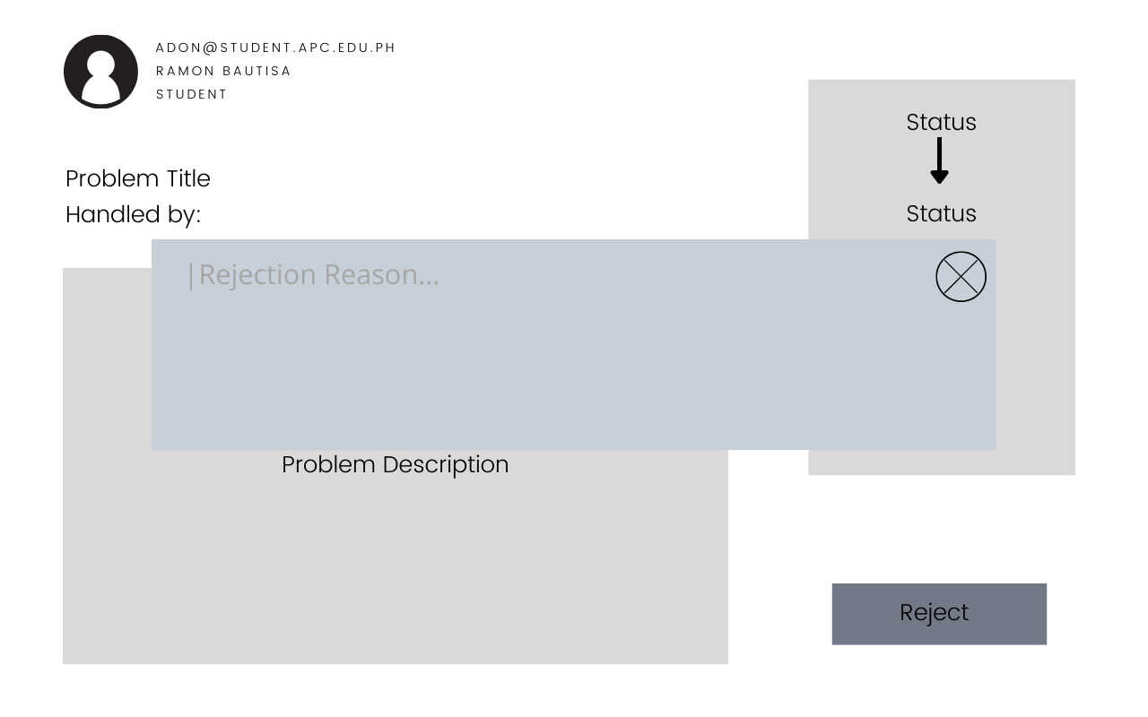

Figure 37 Web View - ITRO Admin Ticket Rejection

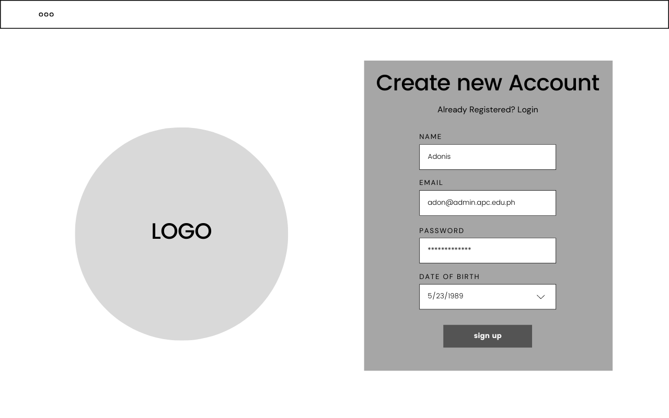

Figure 38 Web View - ITRO Admin Modify ITRO Client Credentials

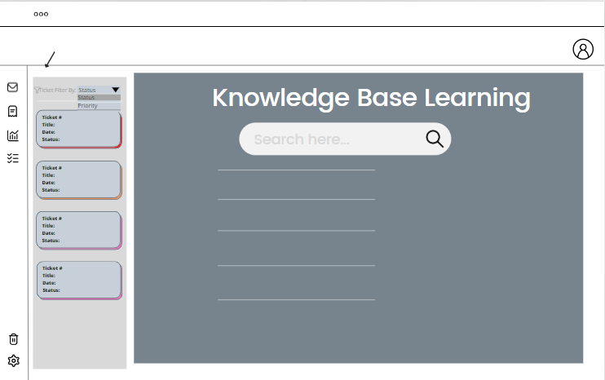

Figure 39 Web View - ITRO Client KB – Landing Page Interface

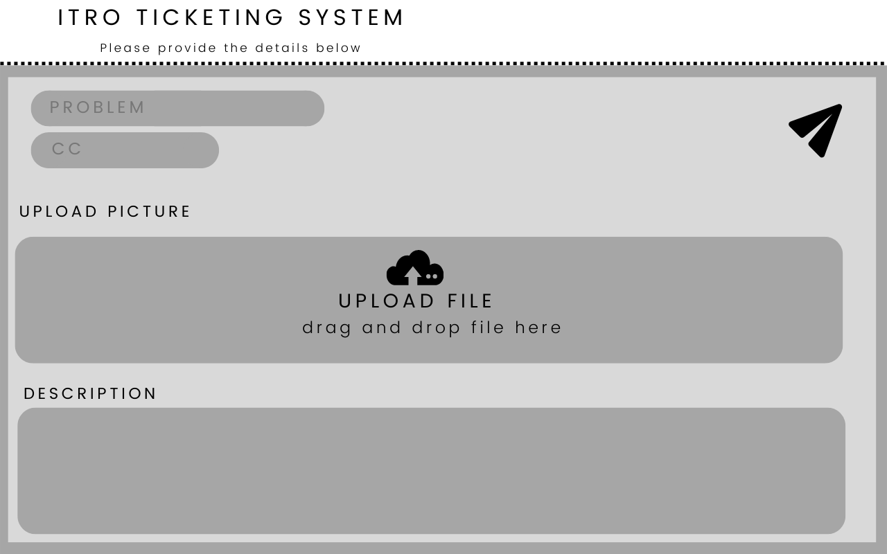

Figure 40 Web View - ITRO Client Send Tickets

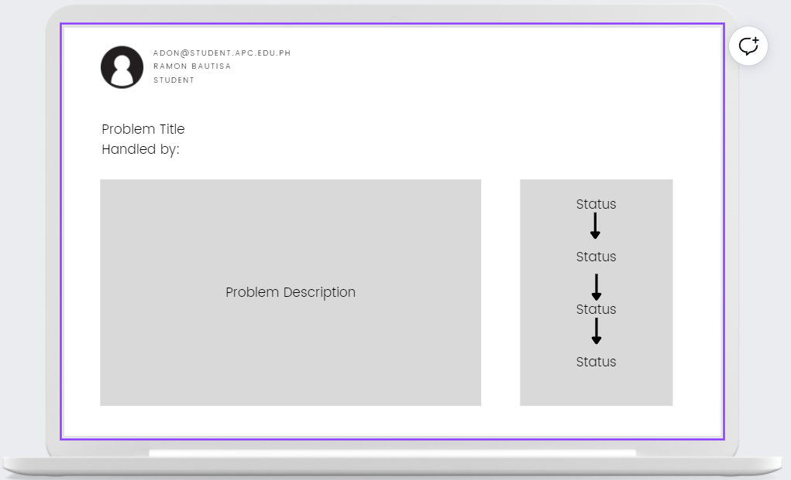

Figure 41 Web View - ITRO Client Open Sent Tickets

#### 4.3.4.2 Mobile View

Figure 42 Mobile View - All Users Login

Figure 43 Mobile View - All User View All Tickets

Figure 44 Mobile View - All Users View All Ticket

Figure 45 Mobile View - ITRO Admin Set Ticket Priority

Figure 46 Mobile View - ITRO Admin Modify ITRO Client Credentials

Figure 47 Mobile View - ITRO Admin Dashboard

Figure 48 Mobile View - ITRO Client Landing Page

Figure 49 Mobile View - ITRO Client KB Interface

Figure 50 Mobile View - ITRO Client Send a Ticket

## 5.3 Use Classes and Characteristics

Table 10 Use Classes and Characteristics

|  |  |  |
| --- | --- | --- |
| ***GENERAL ROLES*** | ***ROLES*** | ***DESCRIPTION*** |
| ***ITRO*** | ***ITRO Admin and ITRO Staff*** | The ITRO would be granted ITRO Admin privileges to view, mark, and respond to the requests and queries sent by users |
| ***ITRO Client*** | ***Teachers*** | Teachers as users could report various incidents involving—but not limited to—school tech problems, teaching method queries, facility maintenance, personal tech concerns, etc. |
| ***Students*** | Similarly, students as users could report various incidents involving—but not limited to—school tech problems, teaching method queries, facility maintenance, personal tech concerns, etc. |

# Conclusion

The objective is to propose a project to the ITRO Client wherein this app can help manage, prioritize, and organize the requests that they will receive from students and teachers alike whether they are inside or outside the school premises. Listed below are the things that we have done and what we are going to do in the future, to reach the team’s desired outcome.

## 6.1 What has been done:

1. Look for an adviser to help the team with decision-making and project proposals.
2. Look for a ITRO Client who needs an IT solution in their respective jobs.
3. Propose a project to cater to the ITRO Client’s needs – in the team’s case, an IT Ticketing Service
4. Jot down ideas for the features of the proposed application
5. Meeting with ITRO – interview about their needs and requests to feature in the app.
6. Meet with adviser – seek for more suggestions and improvement for the app
7. Meet with the ITRO Head – update the status of the application, entertain changes/improvements to be made on the app based on the ITRO Client’s best interests
8. Improve the features of the application
9. Wireframe/Storyboarding
10. Create a mock-up/paper prototype
11. Video Pitch/Teaser
12. Project proposal first installment paper polishing
13. Modelling the system using different UML diagrams
14. UI/UX Design

## 6.2 What will be done for the next PBL subject:

1. Create Survey forms to be disseminated to APC Students and get their insights about the frequent IT-issues that they encounter.
2. Interview the faculty members – topic: frequent IT-related issues
3. Polish the application idea before re-modelling the database
4. Start developing the application after the modeling and design
5. Create and follow 1-week sprints to produce a minimum viable product to be presented to the ITRO Client
6. Completion of the Application
7. Testing for the UI/UX and functions
8. Debugging
9. Retesting
10. Deployment

# References

|  |  |
| --- | --- |
| [1] | "Importance of information technology in today world," Digital Class World, June 2021. [Online]. Available: https://www.digitalclassworld.com/blog/importance-of-information-technology/#:~:text=Information%20technology%20helps%20to%20build,%2C%20storage%2C%20and%20efficient%20communication. [Accessed April 2022]. |
| [2] | M. C. Ferreira, T. G. Dias and J. F. e Cunha, "An In-Depth Study of Mobile Ticketing Services in Urban Passenger Transport: State of the Art and Future Perspectives," 2020. [Online]. Available: https://www.igi-global.com/chapter/an-in-depth-study-of-mobile-ticketing-services-in-urban-passenger-transport/249113. [Accessed April 2022]. |
| [3] | N. A. K. S. Mohamadali and G. J. M., "A NOVEL EVALUATION MODEL OF USER ACCEPTANCE OF," 2010. [Online]. Available: https://www.scitepress.org/papers/2010/26957/26957.pdf. [Accessed April 2022]. |
| [4] | S. Whittaker and C. Sidner, "Email Overload: Exploring Personal Information Management of Email," 1996. [Online]. Available: https://dl.acm.org/doi/fullHtml/10.1145/238386.238530. [Accessed April 2022]. |
| [5] | P. O. Calora, D. S. Maranan and C. Rose, "Exploring the Potential of a Ticketing-Based Student Support System for Open and Distance," December 2020. [Online]. Available: https://ijodel.com/wp-content/uploads/2021/08/004_Calora_et_al.pdf. [Accessed April 2022]. |
| [6] | "Freshdesk Support Desk," Freshworks Inc., 2022. [Online]. Available: https://freshdesk.com/support-desk/features. [Accessed April 2022]. |
| [7] | Spiceworks, "The cloud help desk software for IT. For Free.," Spiceworks, 2022. [Online]. Available: https://www.spiceworks.com/free-help-desk-software/. [Accessed 17 May 2022]. |
| [8] | LiveChat, "Who we are and what we do," LiveChat, [Online]. Available: https://www.livechat.com/about/. [Accessed 19 June 2022]. |
| [9] | LiveChat, "Features: Ticketing System," LiveChat, [Online]. Available: https://www.livechat.com/features/ticketing-system/. [Accessed 19 June 2022]. |
| [10] | Hiver, "Customer Service Software for Education | Hiver," Hiver, [Online]. Available: https://hiverhq.com/helpdesk-software-education. [Accessed 19 June 2022]. |
| [11] | J. Short, "The 9 Best Help Desk Software for Schools and Universities," HelpScout, 8 June 2022. [Online]. Available: https://www.helpscout.com/blog/help-desk-software-for-schools/. [Accessed 19 June 2022]. |
| [12] | Enlyft, "Companies using LiveAgent," Enlyft, [Online]. Available: https://enlyft.com/tech/products/liveagent. [Accessed 19 June 2022]. |
| [13] | LiveAgent, "Features - LiveAgent," LiveAgent, [Online]. Available: https://www.liveagent.com/features/. [Accessed 19 June 2022]. |
| [14] | Aendesk, "Education Help Desk Software & Customer Service Software," Zendesk, [Online]. Available: https://www.zendesk.com/education/. [Accessed June 2022]. |
| [15] | H. Scout, "Help desk Software for Education - Help Scout," Help Scout, [Online]. Available: https://www.helpscout.com/industry/education/. [Accessed June 2022]. |
| [16] | C. o. t. H. Cross, "IT Service Desk | College of the Holy Cross," Colleg of the Holy Cross, [Online]. Available: https://www.holycross.edu/its-help-desk/it-services/support-training/it-service-desk. [Accessed June 2022]. |
| [17] | "Freshworks: About Us," Freshworks Inc., 2022. [Online]. Available: https://www.freshworks.com/company/about/?source=freshdesk&medium=referral&campaign=fdesk_footer_main. [Accessed April 2022]. |

# Appendices

## Appendix A: Project Vision

Table 11 Project Vision

|  |  |  |
| --- | --- | --- |
| **FOR** | APC Information Technology and Resource Office (ITRO) | ITRO Clients |
| **WHO** | Needs a way to organize and prioritize ITRO-related requests of students and teachers. | Needs a tool to organize their requests and see its status |
| **THE** | RAMs Corner: ITRO Ticketing Service | |
| **IS A** | Reactive Web App | |
| **THAT** | allows prioritization, organization, and designation of ITRO-related tasks and requests | allows automation of requests for uniformity and accuracy |
| **UNLIKE** | Using e-mails to receive requests | Using emails to write and send a request |
| **OUT PRODUCT** | Can be used in both web and mobile app for the ITRO’s convenience | Can be used in both web and mobile app for the ITRO Clients’ convenience |

## Appendix B: Schedule

## Appendix C: Product Roadmap

Table 12 Product Roadmap

|  |  |  |  |
| --- | --- | --- | --- |
| **USERS** | **MNTSDEV** | **MSYADD1** | **MCSPROJ** |
| **ITRO**  **(ITRO Admin, ITRO Staff)** |  |  | * Automatic ticket-assignment * Ticket-Spamming Prevention * Modify user credentials * Problem Ticket/Incident Ticket categorization * Generate Reports * Monitoring Tasks assigned to staff * ITRO Admin manual ticket-assignment * View Insights/Analytics * Setting tickets’ urgency |
| **Students and Teachers**  **(ITRO Clients)** |  |  | * Automated ticket creation * Notification Filter * Categorization of ITRO-related tasks in subject field * User Ticket Creation * Cc Field * KB (Knowledge-based) |
| **All Users(ITRO Admin, ITRO Staff, ITRO Client)** | * Paper Prototype | * UI/UX Design | * User Login * Forgot Password * View All Tickets * Ticket Notification * Filter Ticket Status |

## Appendix D: Team Meetings

*Microsoft Teams – Meeting with Members: Apr-11-2022*

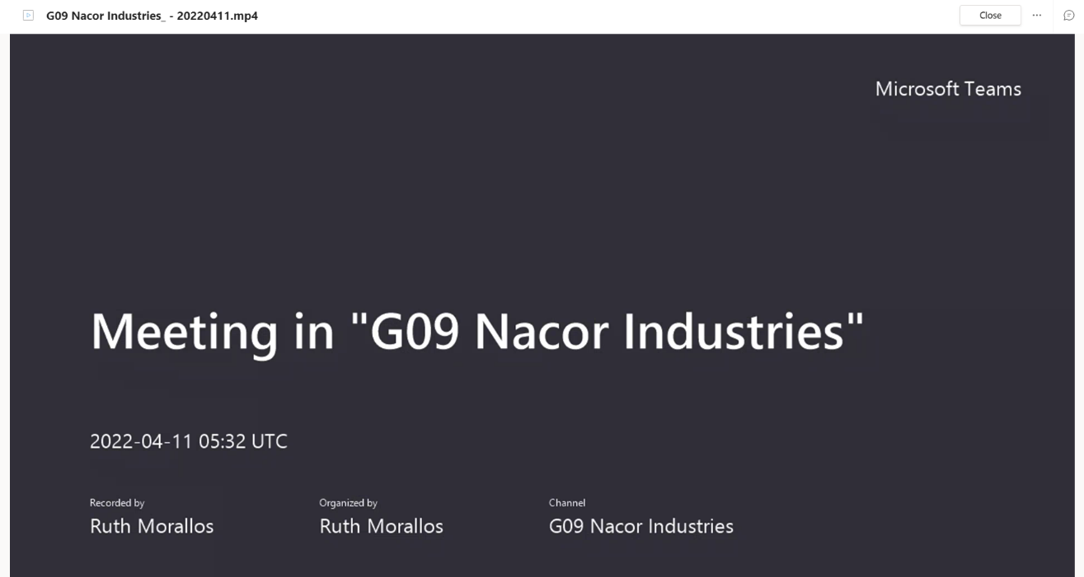

Figure 51 Microsoft Teams – Meeting with Members (1)

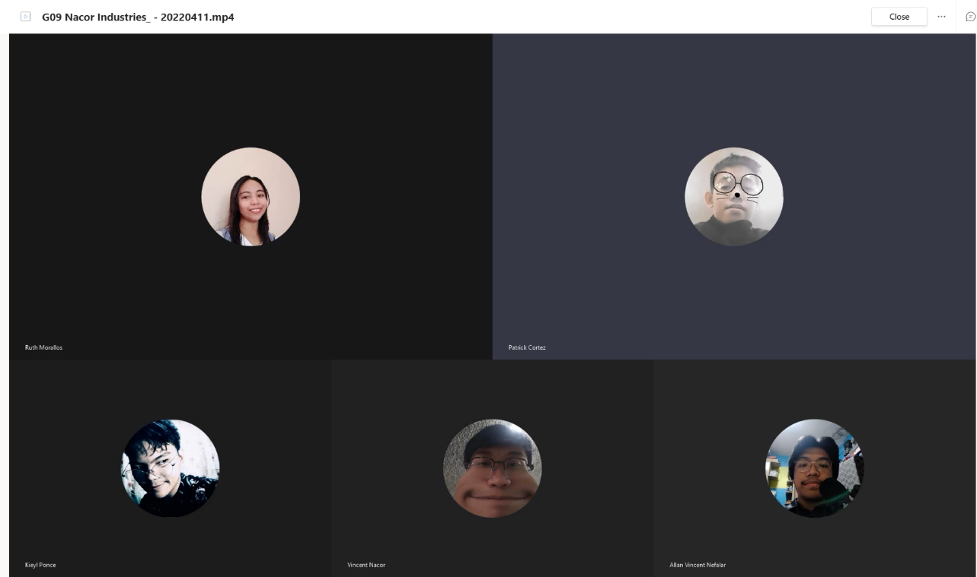

Figure 52 Microsoft Teams – Meeting with Members (2)

*Face-to-face – Meeting with Members: Apr-19-2022*

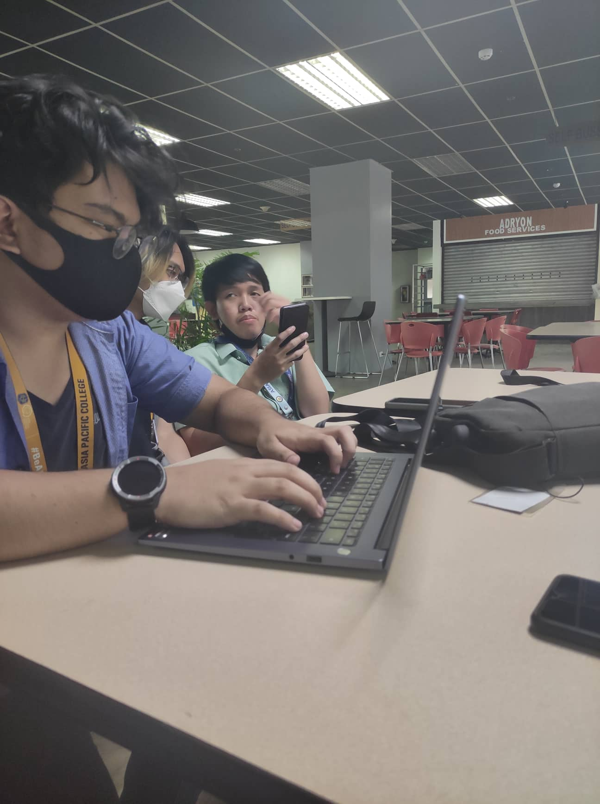

Figure 53 Face-to-face – Meeting with Members (1)

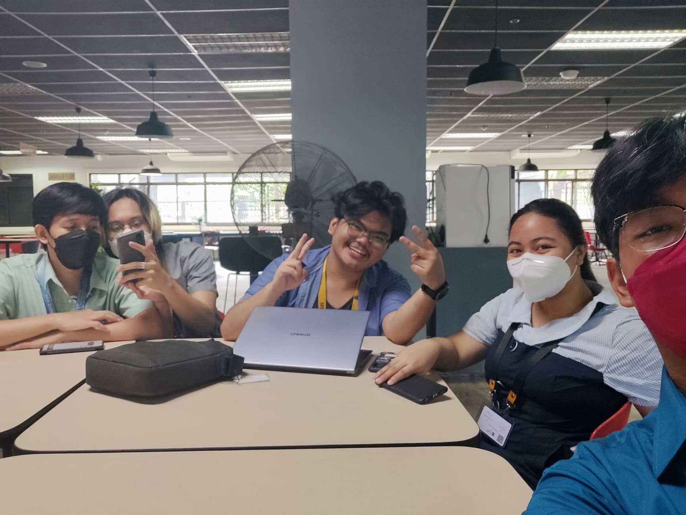

Figure 54 Face-to-face – Meeting with Members (1)

*Face-to-face – Meeting with Members:* Apr-22-2022

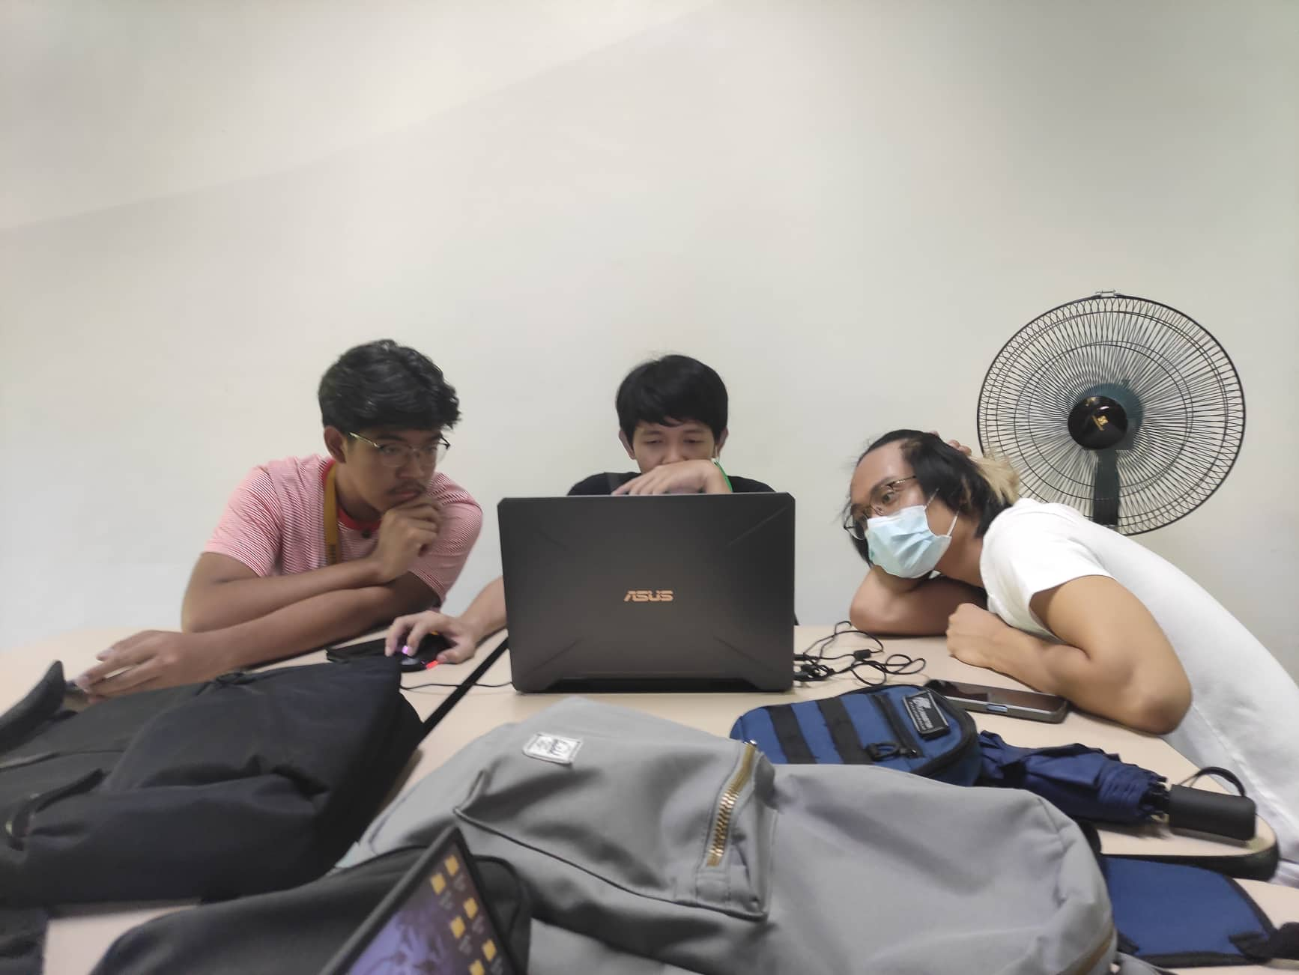

Figure 55 Face-to-face – Meeting with Members (3)

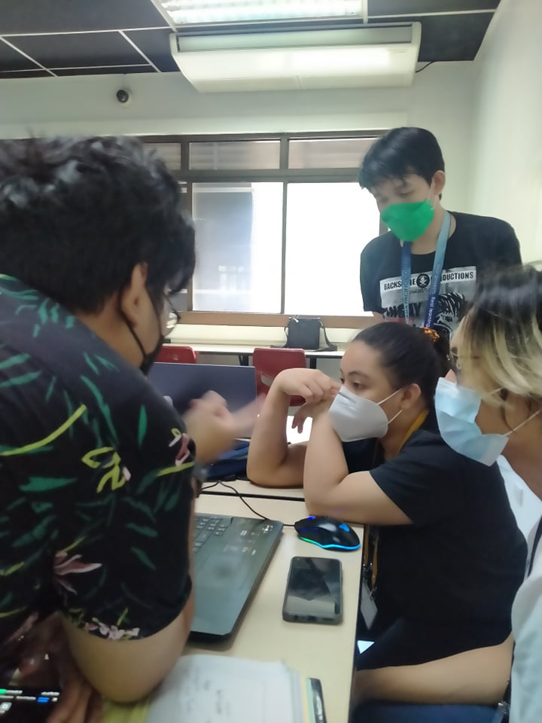

Figure 56 Face-to-face – Meeting with Members (4)

*Microsoft Teams – Progress Meeting with Members: Apr-27-2022*

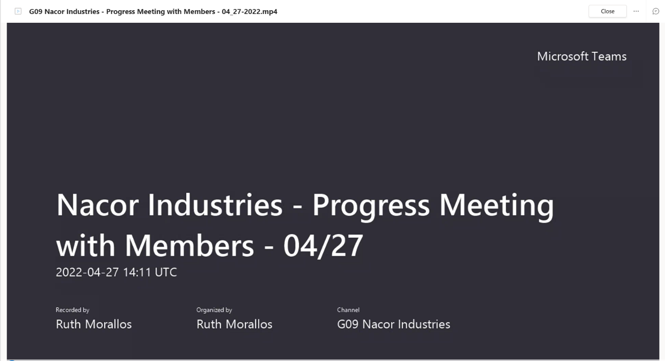

Figure 57 Microsoft Teams – Meeting with Members (3)

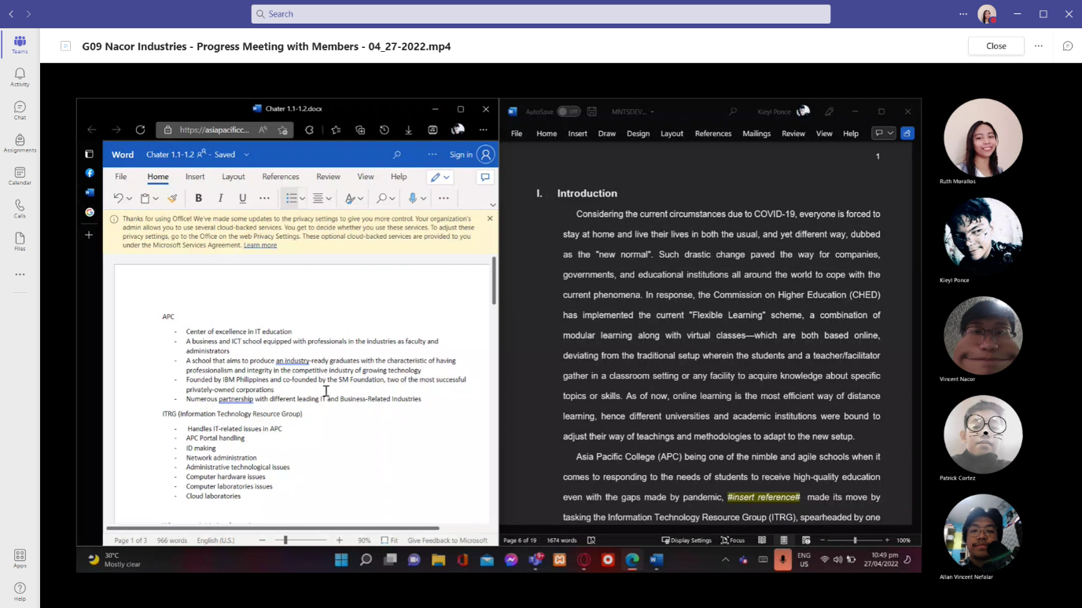

Figure 58 Microsoft Teams – Meeting with Members (4)

*Microsoft Teams – Progress Meeting with Members: May-22-2022*

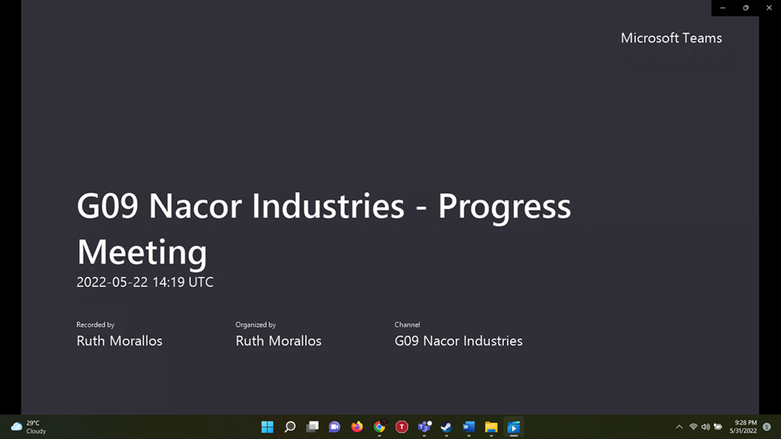

Figure 59 Microsoft Teams – Meeting with Members (5)

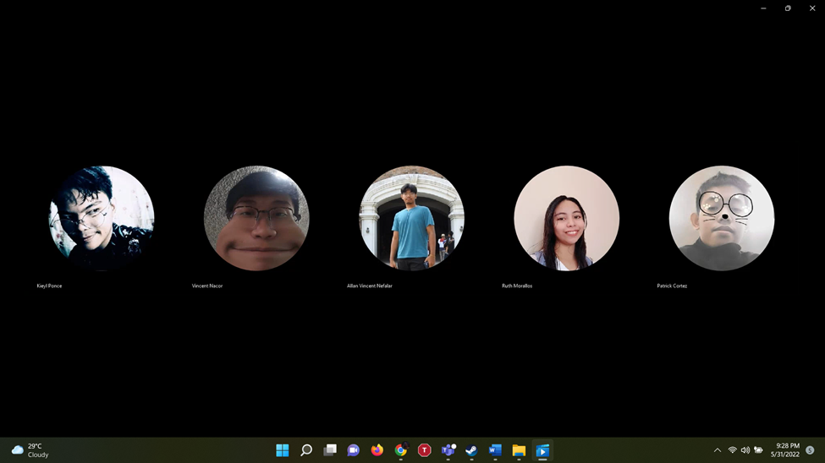

Figure 60 Microsoft Teams – Meeting with Members (6)

*Microsoft Teams – Meeting with Members: May-30-2022*

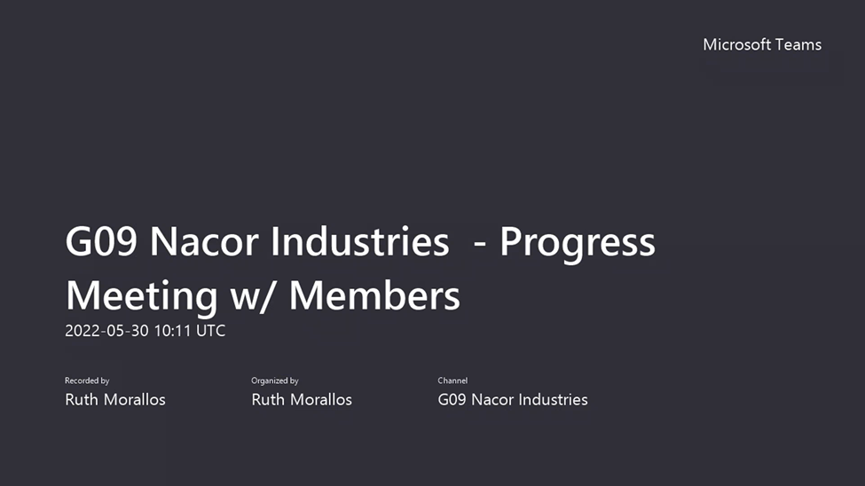

Figure 61 Microsoft Teams – Meeting with Members (7)

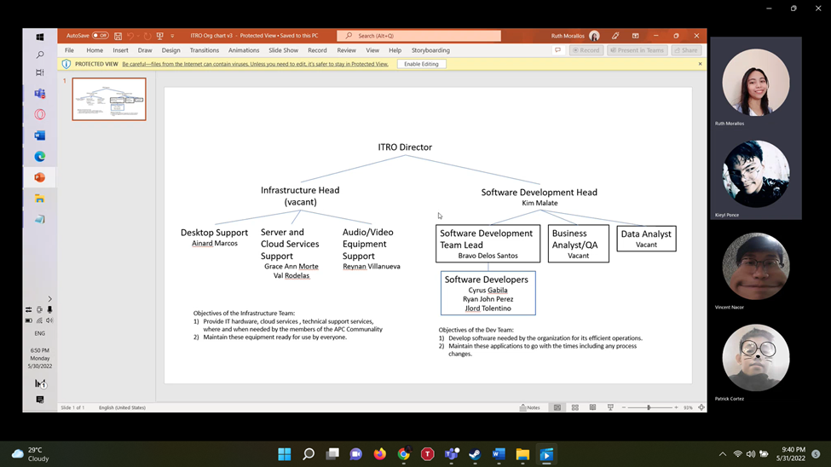

Figure 62 Microsoft Teams – Meeting with Members (8)

*Face-to-face – Meeting with Members:* May-31-2022

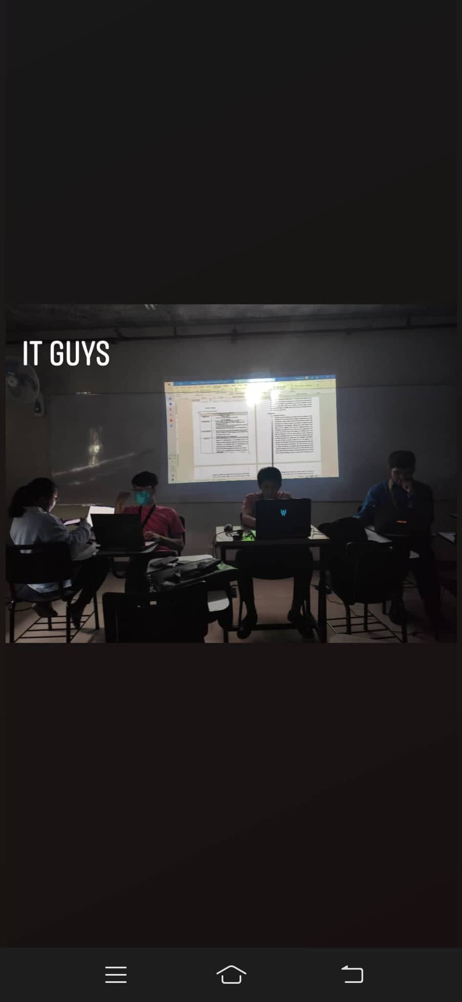

Figure 63 Face-to-face – Meeting with Members (5)

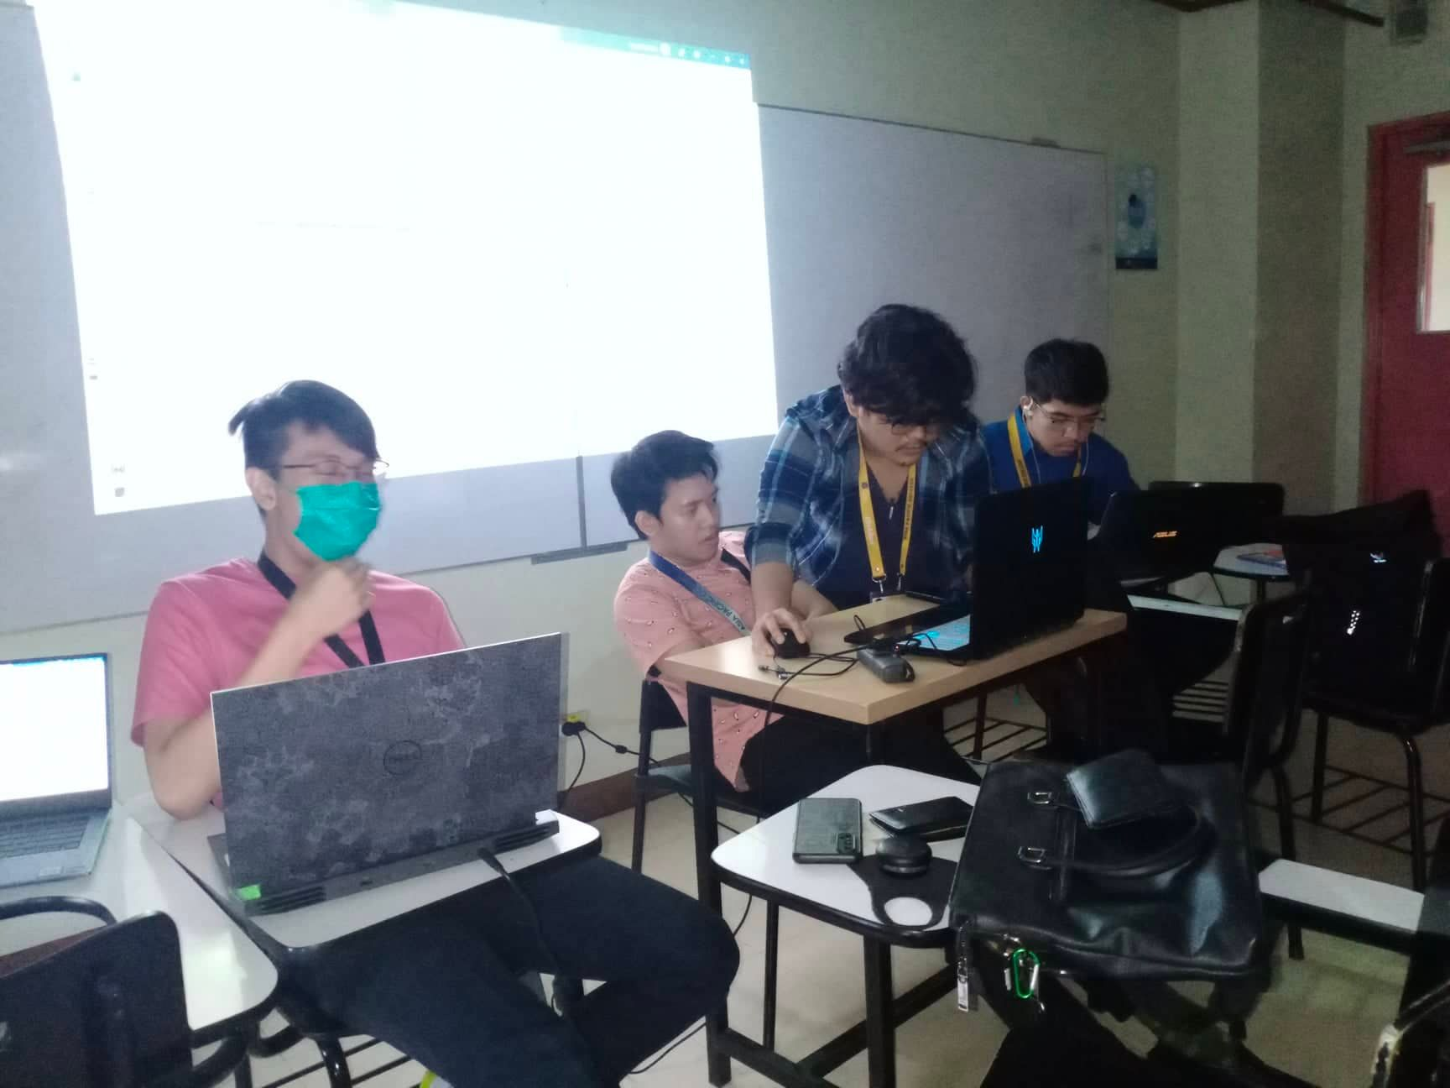

Figure 64 Face-to-face – Meeting with Members (6)

Table 13 Minutes of Meeting - Nacor Industries Members

|  |
| --- |
| **Minutes of the Meeting with Nacor Industries Members:** |
| **April 10, 2022** |
| Topics:   1. Project proposal features  * live chat * automated chat reply * categorization * prioritization (P1, P2...P3)  1. Prospect ITRO Client  * ITRO * status update (if there is an agreed schedule for ITRO Client meeting)  1. Proposal Documentation  * Setting meeting schedule with project adviser * Agreed Time: Tuesdays - 9:00 am * Setting up a f2f meeting with members * Agreed Time Tuesdays/Fridays - 8:00 am  1. Examples of Related System  * Help Desk (video about ticketing system)  1. Scope of the Project  * 1st Term – Documentation * 2nd term – Data Modelling * 3rd Term – Working Application |
| **April 19, 2022** |
| Topics:   1. Feature Planning  * suggestions from adviser  1. Paper Progress  * Problem Rundown * User Need Statement * Project Context(tentative) * Statement of the Problem(tentative) |
| **April 22, 2022** |
| Topics:   1. Feature Planning  * suggestions from ITRO Client  1. Paper Progress  * Wireframe/Screens * Storyboarding * Chapter 1 |
| **May 22, 2022** |
| Topics:  A.    ITRO Client Statement Transcript   * + - * Questions       * Signed Answers |
| **May 30, 2022** |
| Topics:  A.    Update wireframe  -          Polishing wireframe of both mobile and web  -          Adding necessary functions in both mobile and web wireframe    B.    Reviewing the org chart  -          Reviewing the assigned tasks that people in ITRO do |
| **May 31, 2022** |
| Topics:  A.    Meeting with ITRO Client  -          Meeting with Sir Jojo about SOP/Objectives  -          Interview with few questions regarding SOP    B.     Meeting with adviser  -          Discussed about how Ticketing Service works  -          Adding/Removing features in ticketing system  -          Polishing of papers    C.   Video Shooting  -          Gathered a few Clips for pitch video |

*Microsoft Teams – Meeting with Ms. Roselle Wednesday Gardon (Course Adviser):*

*Apr-11-2022*

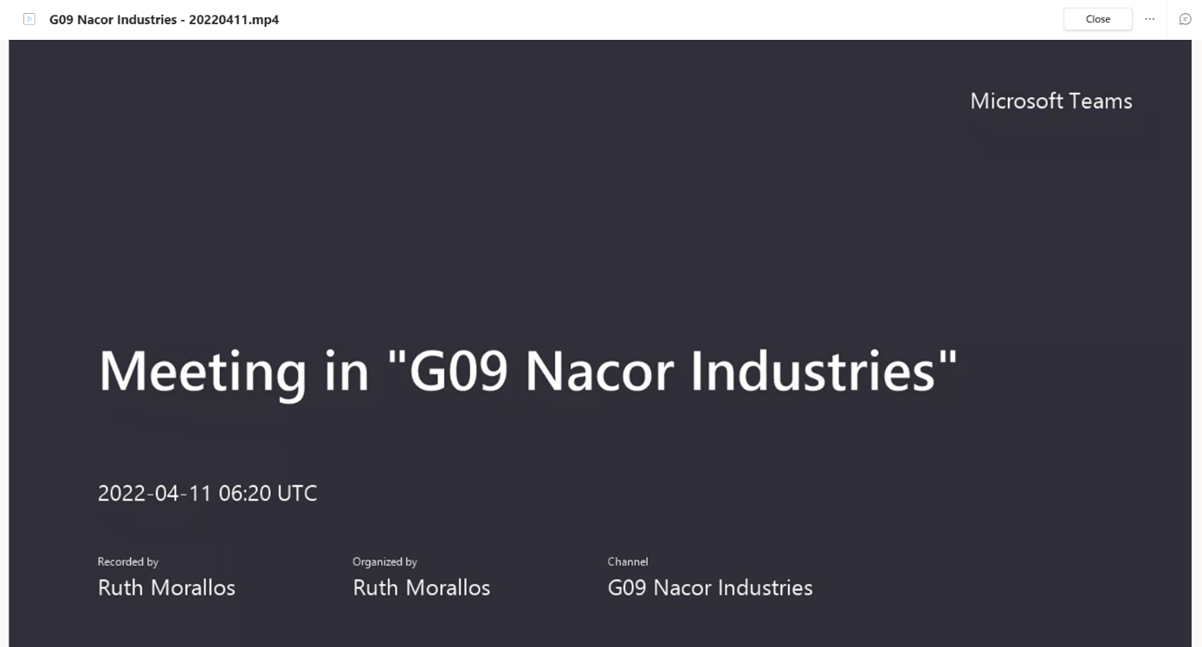

Figure 65 Microsoft Teams – Meeting with Ms. Roselle Wednesday Gardon (1)

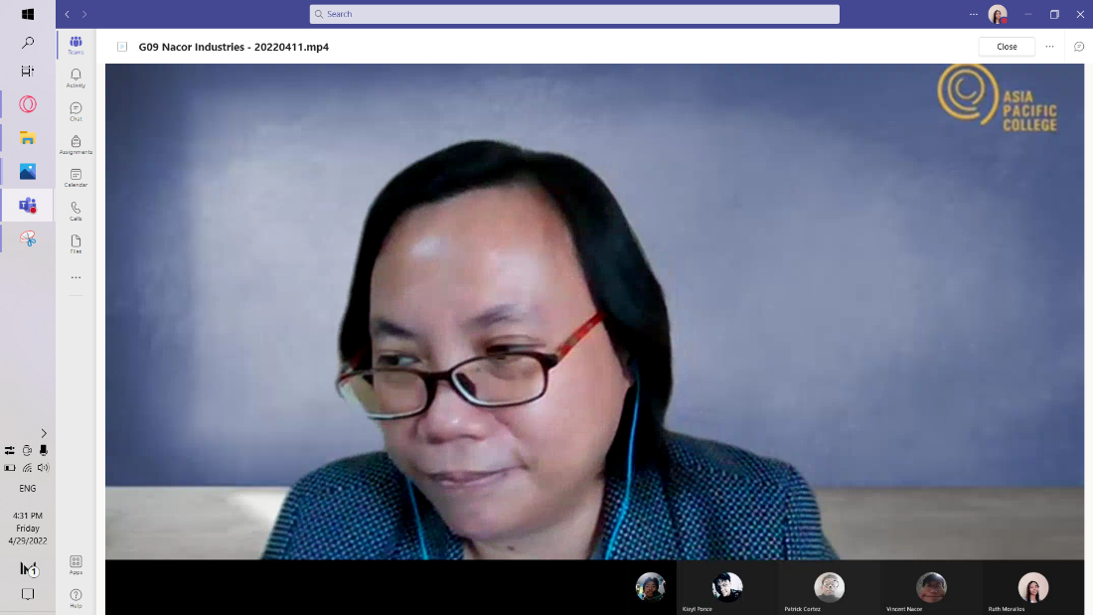

Figure 66 Microsoft Teams – Meeting with Ms. Roselle Wednesday Gardon (2)

*Microsoft Teams – Meeting with Ms. Roselle Wednesday Gardon (Course Adviser):*

*June-02-2022*

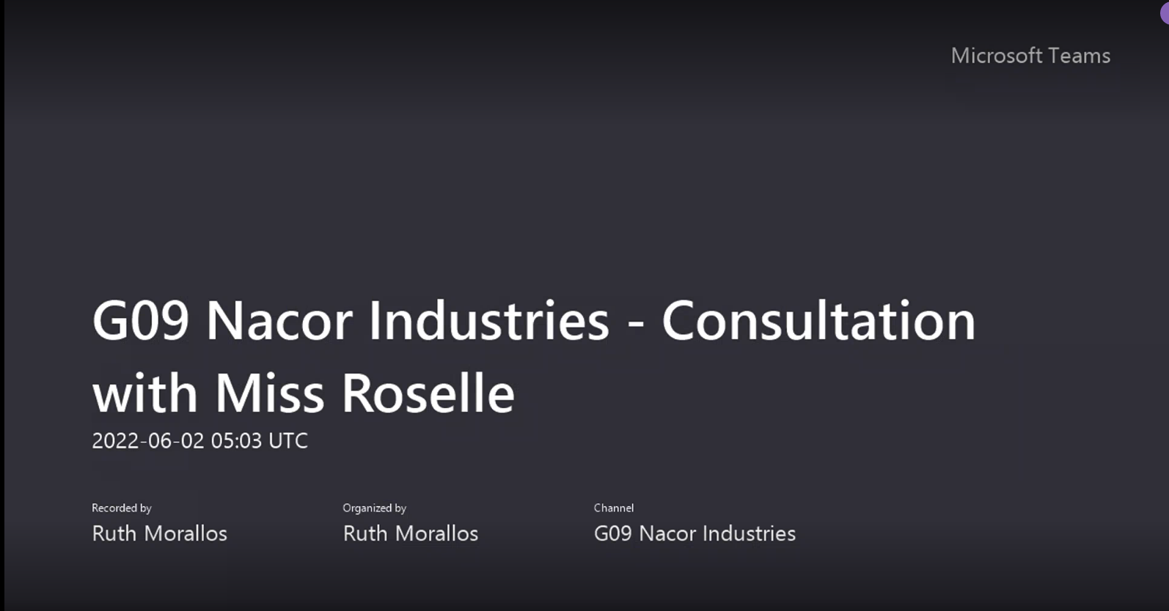

Figure 67 Microsoft Teams – Meeting with Ms. Roselle Wednesday Gardon (3)

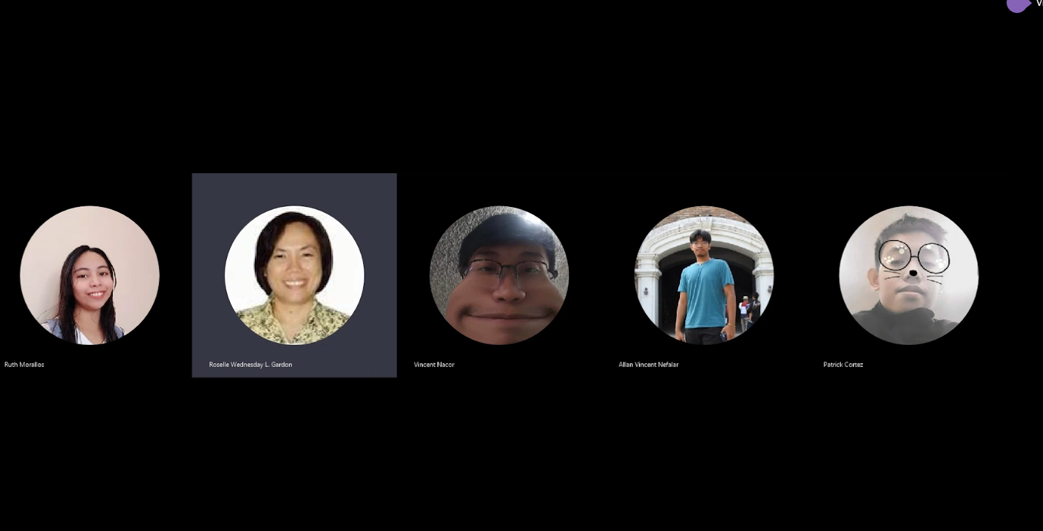

Figure 68 Microsoft Teams – Meeting with Ms. Roselle Wednesday Gardon (4)

Table 14 Minutes of Meeting - with Miss Roselle Wednesday Gardon

|  |
| --- |
| **Minutes of the Meeting with Miss Roselle Wednesday Gardon (Course Adviser)** |
| **April 10, 2022**  Topics:  A. Project update   * ITRO Client update * What to finish:   1. Send an email   2. Follow up with proposal of the project in mind   3. Ask if the team can work with the ITRO Client and if they want to customize the proposed plan   B. What is the project all about?   * ticketing service for requests and disputes   C. Signed form update   * Adding titles can be temporary |
| **June 2, 2022** |
| Topics:  A.    Meeting with Subject Adviser  -         Adding/Removing words for better grammar construction  -          Showing both mobile and web wireframe for approval  - Discussing possible questions from panelists |

*Face-to-face Meeting and Audio Recording Screenshot: – with Sir Alvin Limpin (Project Adviser): Apr-19-2022*

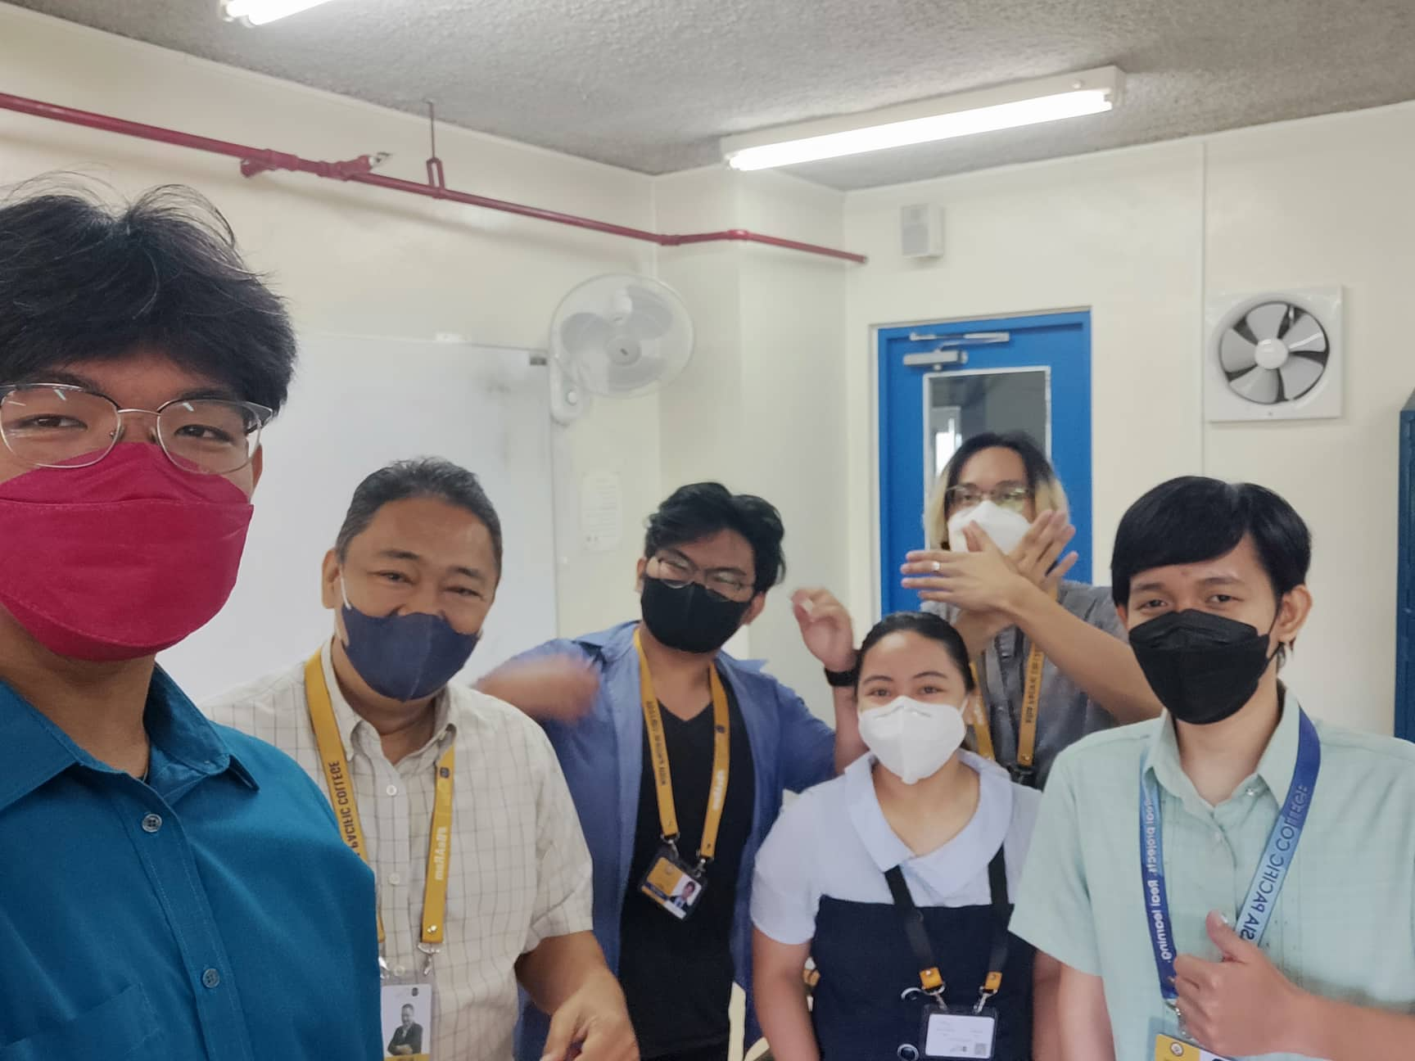

Figure 69 Face-to-face Meeting – with Sir Alvin Limpin (1)

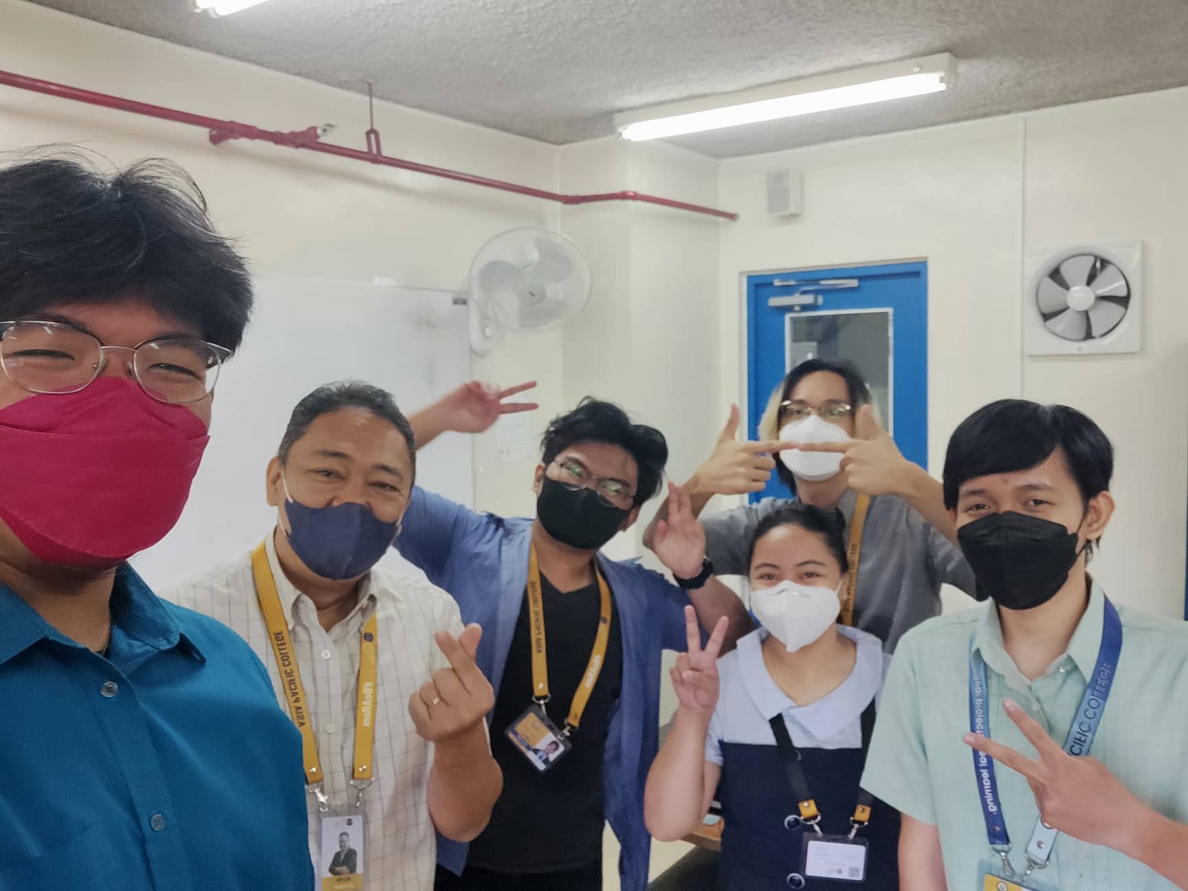

Figure 70 Face-to-face Meeting – with Sir Alvin Limpin (2)

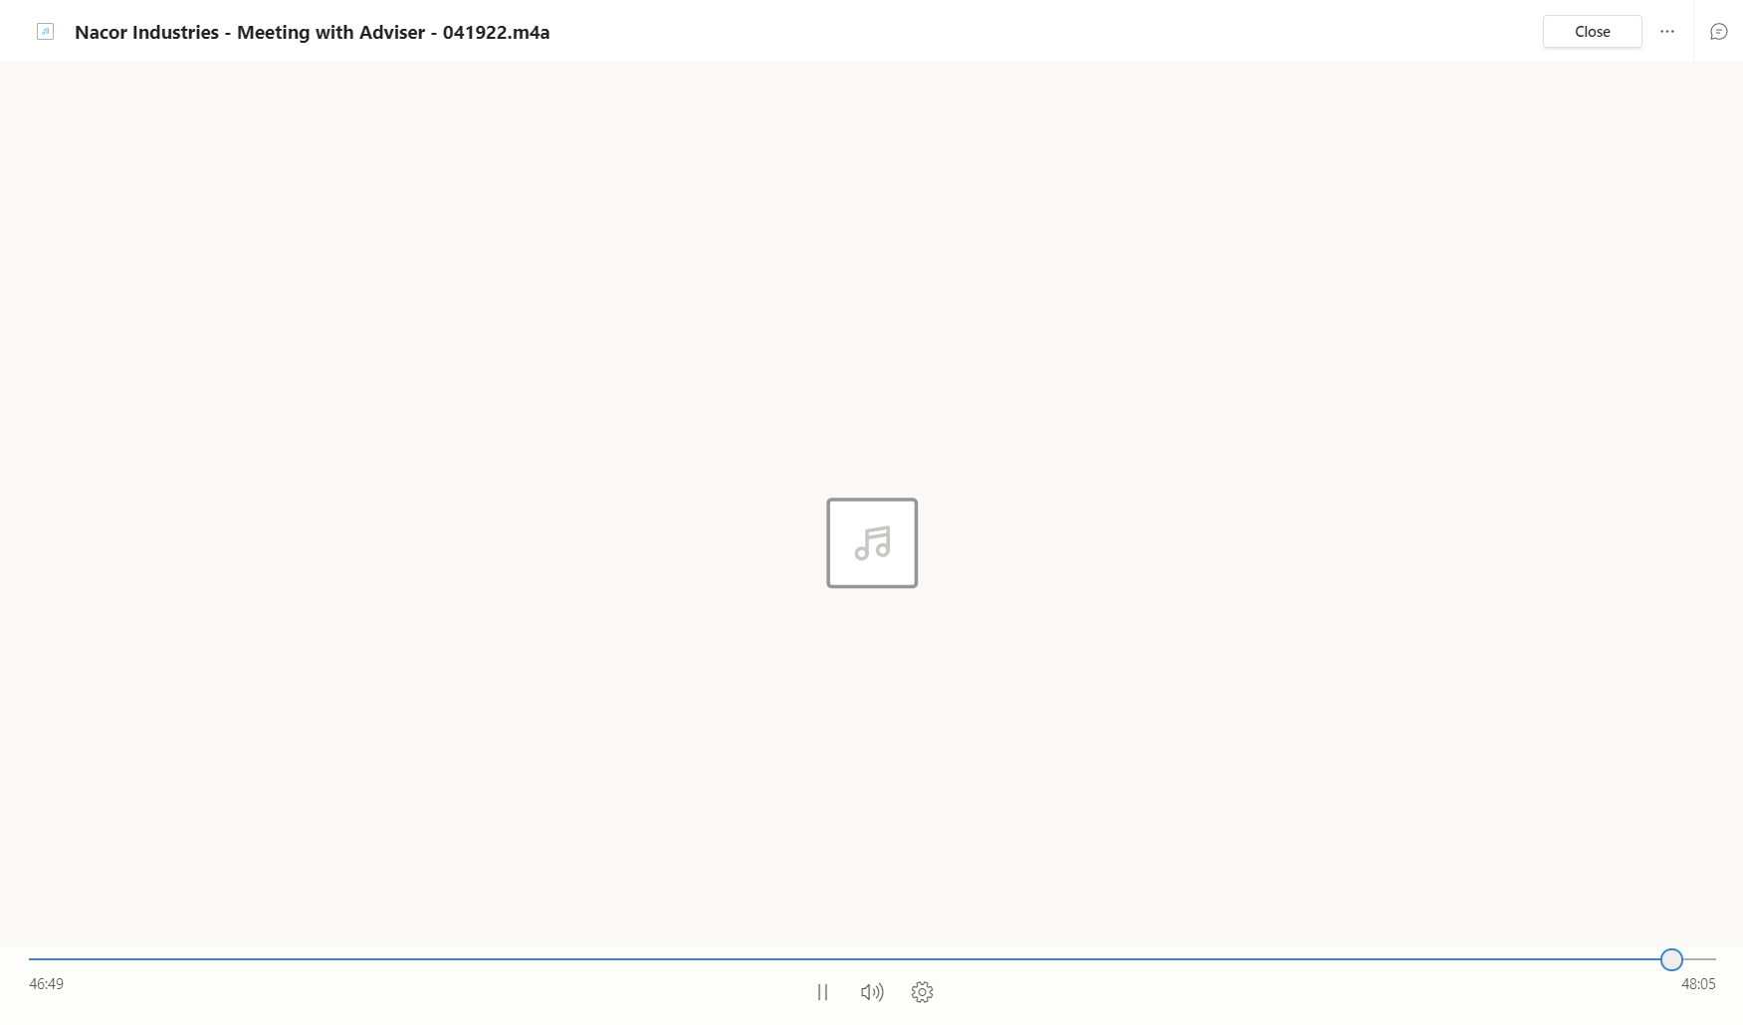

Figure 71 Audio Recording Screenshot - Meeting with Sir Alvin

*Face-to-face Meeting and Audio Recording Screenshot: – with Sir Alvin Limpin (Project Adviser): May-31-2022*

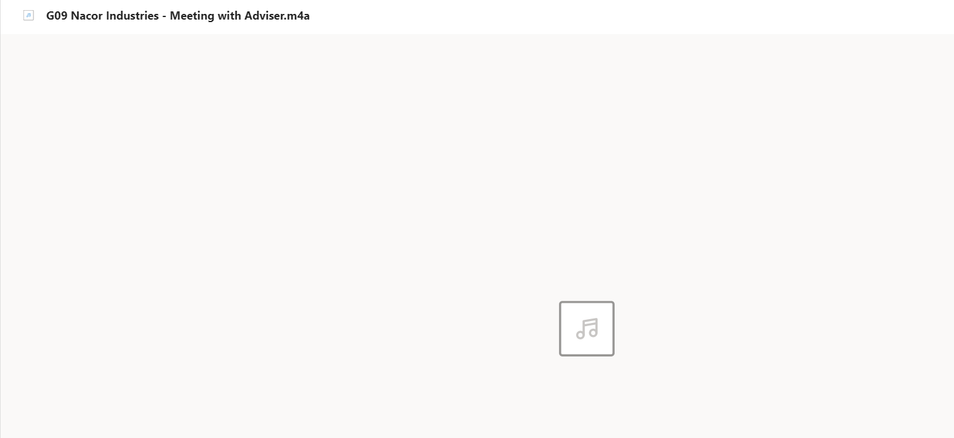

Figure 72 Audio Recording Screenshot - Meeting with Sir Alvin (1)

Table 15 Minutes of Meeting - with Sir Alvin Limpin

|  |
| --- |
| **Minutes of the Meeting with Sir Alvin Limpin (Project Adviser)** |
| **April 19, 2022**  Topics:   1. Where can ticketing system be used in APC  * overload works * plumbing * electrical * computers  1. Which department can the Ticketing System be applied to?  * security * building maintenance * ITRO * Department with overloading tasks  1. ITRO Client schedule inquiry  * who is the prospect ITRO Client * When was the scheduled meeting for the ITRO Client  1. What does ITRO do  * confirming IT-Related requests * laboratory fixes * computer issue * broken ports * issue in website * anything computerization * handling APC Website  1. Issue with ITRO Workflow  * hard to contact personnel * can be contacted via e-mail at most   F. Assume that in the ticketing system: how do these things work   * user sends a ticket in a form of e-mail to the ITRO Client (ITRO Admin) * email landing to the website on the backend/ITRO, * ITRO Admin gives priority to ticket * P1   * Most urgent  * Executives are losing money  * e.g., internet connection, mainframe is down   * P2... and so on * ITRO Admin assigns the ticket to free personnel * monitoring tickets on a website * How can a ticket be sent: * Via email * via chat - automatic convert to email after sending   H. Review the following   * charts on how apps/ticketing system manages tickets   I. Create an algorithm on the following   * how to approve tickets * how to generate ticket reports |
| **May 31, 2022** |
| Topics:  A.    Meeting with Adviser   * + Discussed about how Ticketing Service works   + Adding/Removing features in ticketing system   + Polishing of papers |

*Face-to-face Meeting and Audio Recording Screenshot – with Sir Jose Castillo (ITRO Client – ITRO Head): Apr-22-2022*

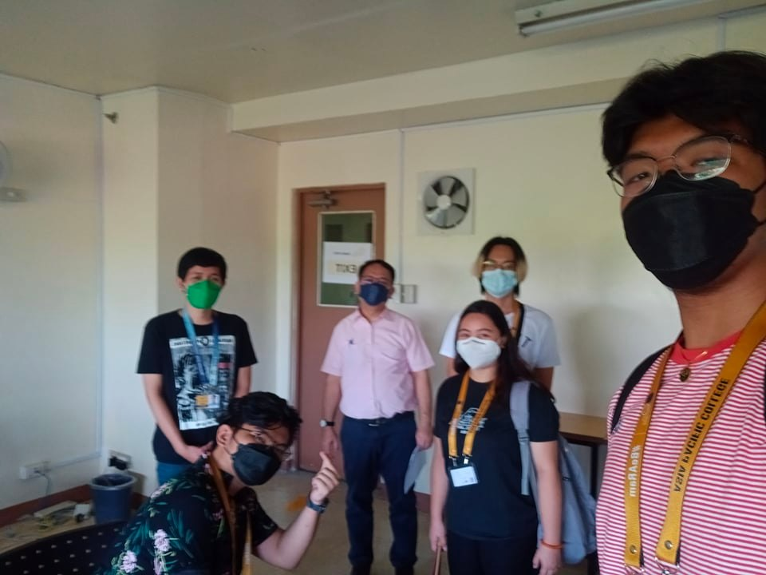

Figure 73 Face-to-face Meeting – with Sir Jose Castillo (1)

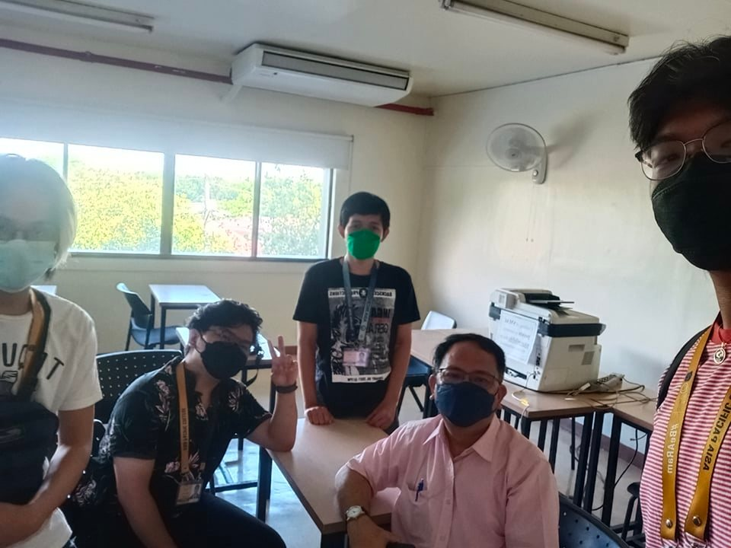

Figure 74 Face-to-face Meeting – with Sir Jose Castillo (2)

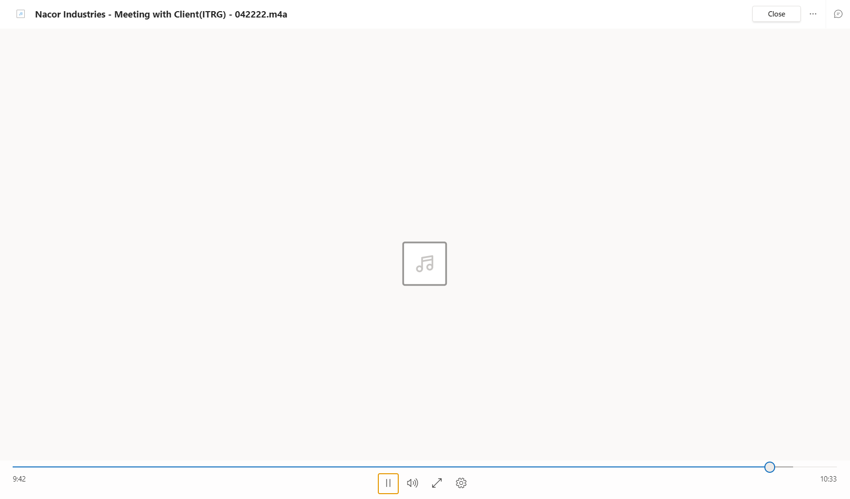

Figure 75 Audio Recording Screenshot - Meeting with Sir Jose Castillo

*Microsoft Teams Meeting Screenshot – with Sir Jose Castillo (ITRO Client – ITRO Head): May-10-2022*

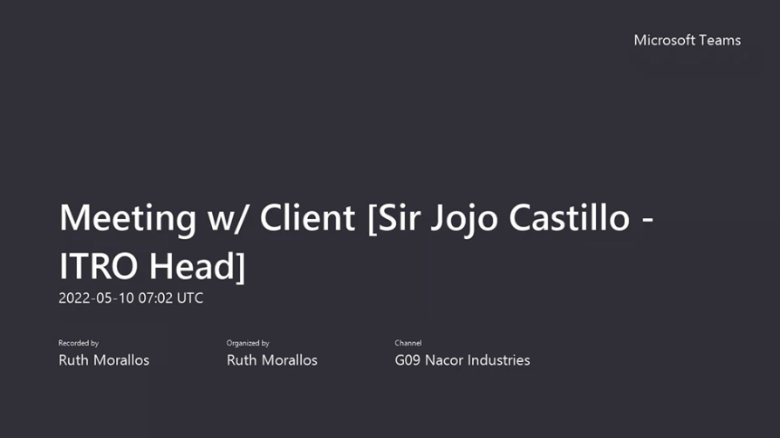

Figure 76 Microsoft Teams – Meeting with Sir Jojo Castillo (1)

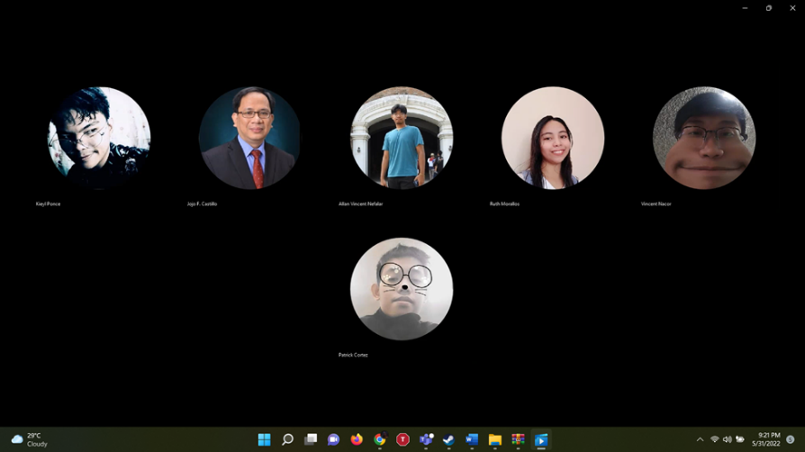

Figure 77 Microsoft Teams – Meeting with Sir Jojo Castillo (2)

*Microsoft Teams Meeting Screenshot – with Sir Jose Castillo (ITRO Client – ITRO Head): May-17-2022*

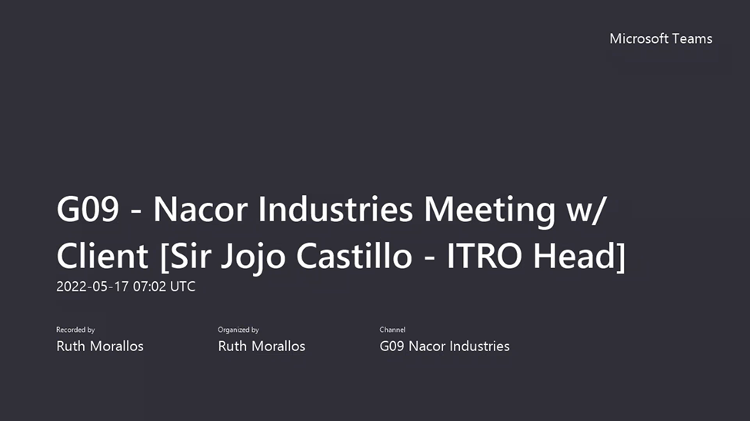

Figure 78 Microsoft Teams – Meeting with Sir Jojo Castillo (3)

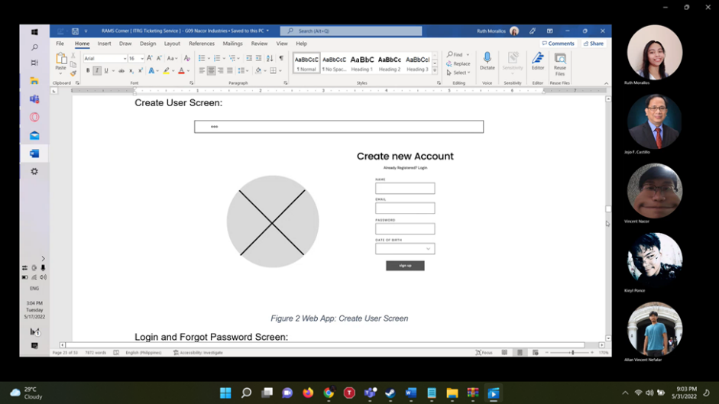

Figure 79 Microsoft Teams – Meeting with Sir Jojo Castillo (4)

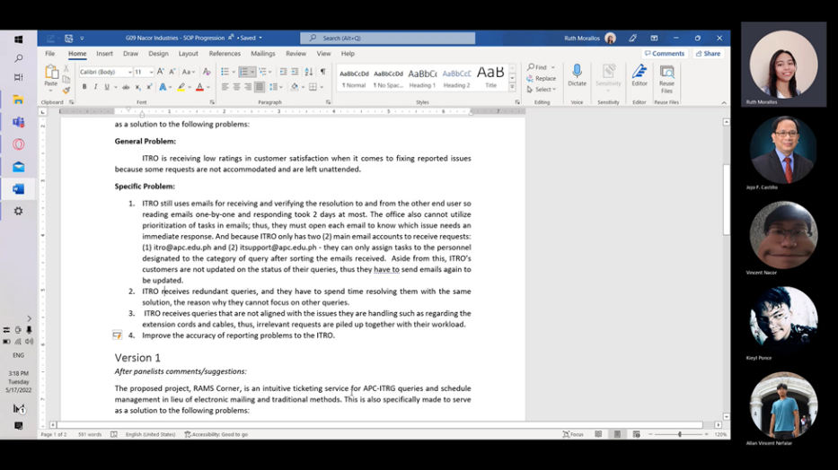

Figure 80 Microsoft Teams – Meeting with Sir Jojo Castillo (5)

*Microsoft Teams Meeting Screenshot – with Sir Jose Castillo (ITRO Client – ITRO Head): May-24-2022*

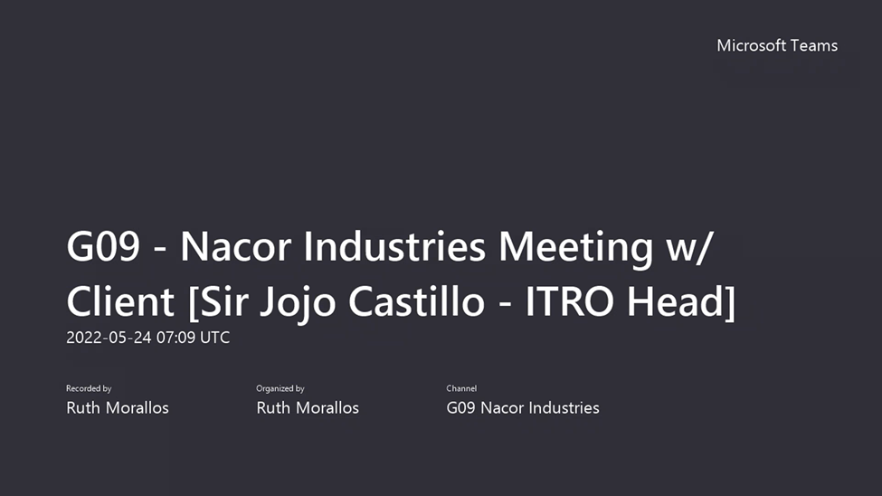

Figure 81 Microsoft Teams – Meeting with Sir Jojo Castillo (6)

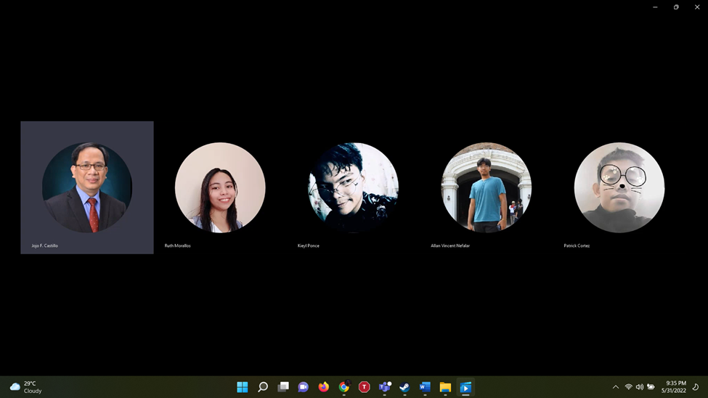

Figure 82 Microsoft Teams – Meeting with Sir Jojo Castillo (7)

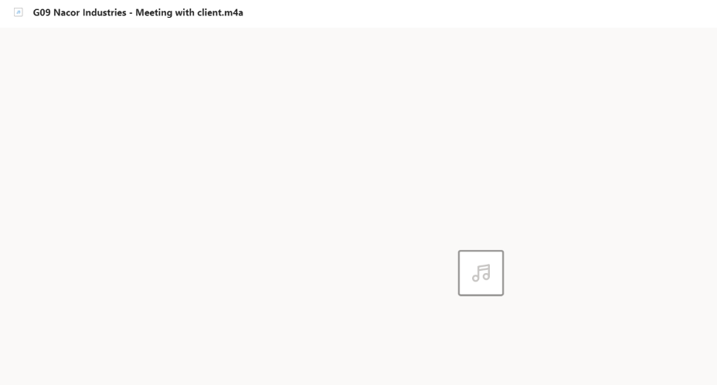

Figure 83 Audio Recording Screenshot - Meeting with Sir Jose Castillo (1)

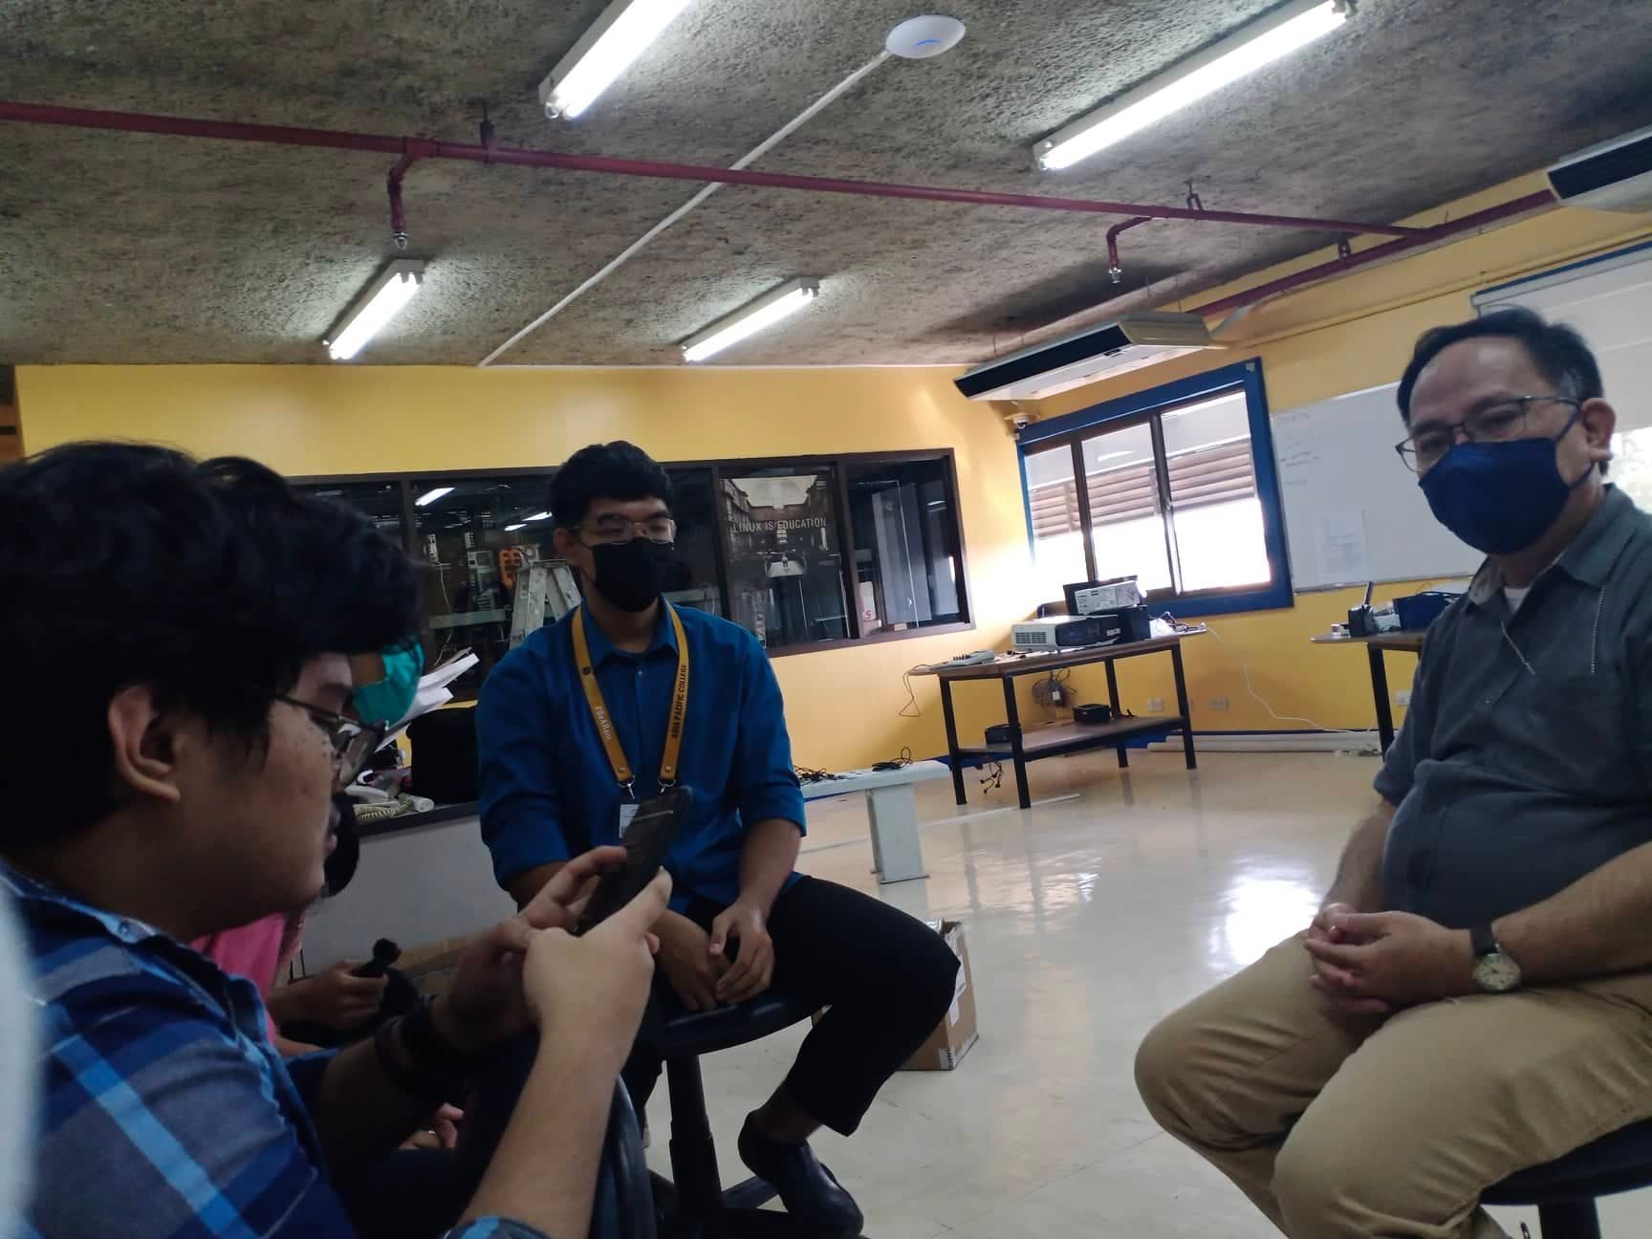

Figure 84 Face-to-face Meeting – with Sir Jose Castillo (3)

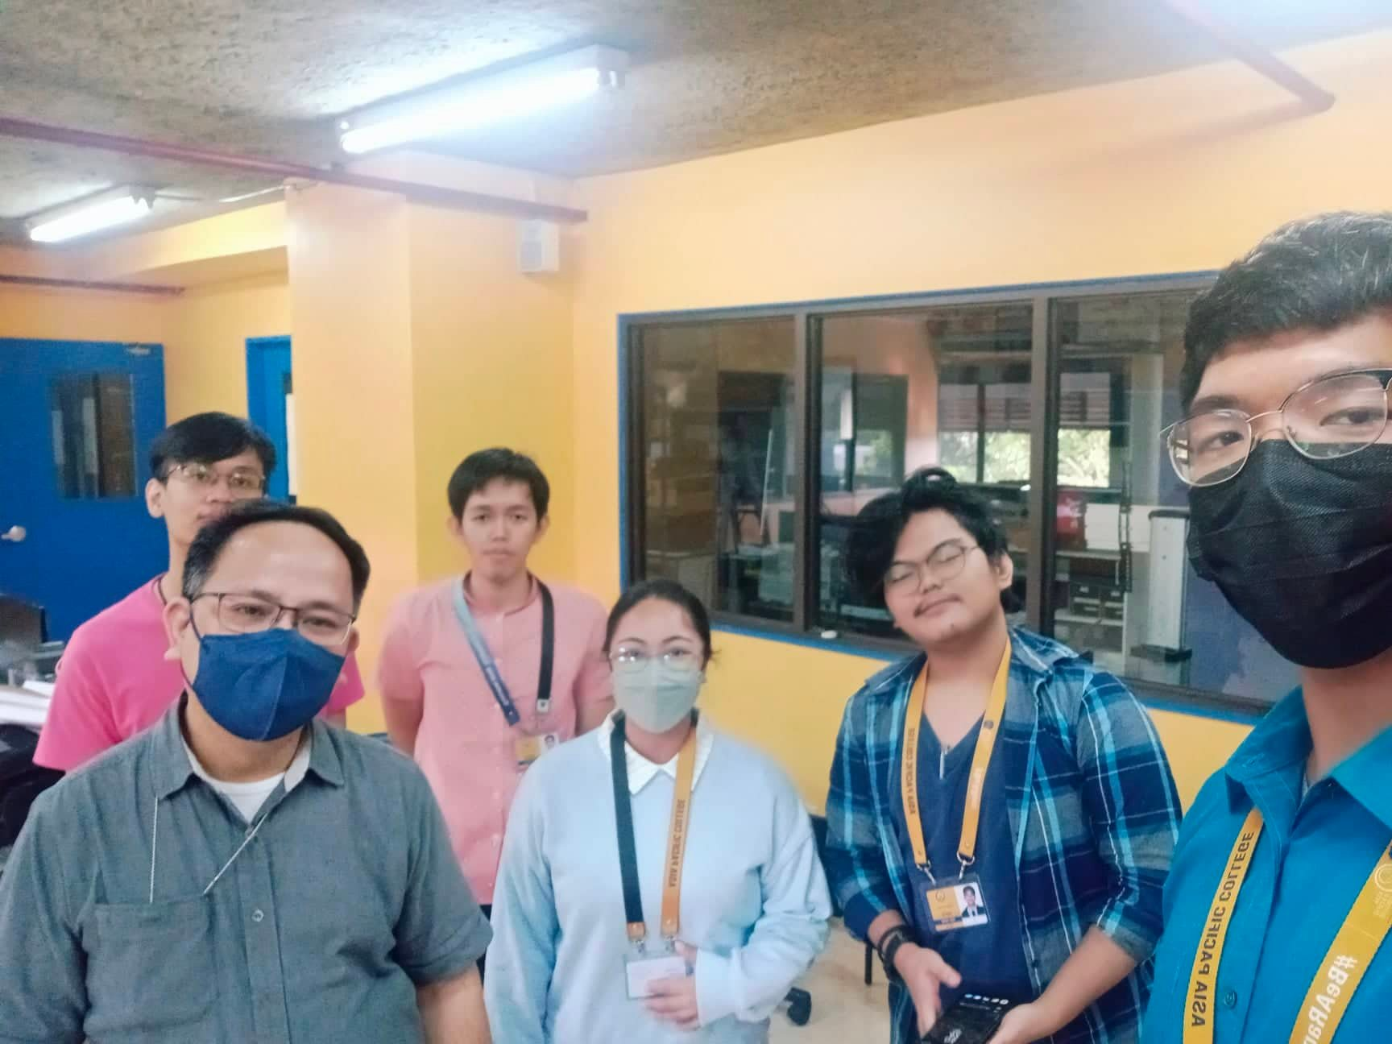

Figure 85 Face-to-face Meeting – with Sir Jose Castillo (4)

Table 16 Minutes of Meeting - with Sir Jose Castillo

|  |
| --- |
| **Minutes of the Meeting with Sir Jojo Castillo (ITRO Client)** |
| **April 22, 2022**  Topics:  A. what we are informed of about ITRO:  - lots of inquiries about system maintenance  - unattended emails  B. what we plan to do:  - mobile/web application ticketing system  - used by student/teachers  - can send queries with tags and captions/message  - if the question is common, there will be KB’s  - answers are provided by the ITRO Client  - automated replies for usual questions in chat  - if needs personal assistance   * creating tickets based on schedule * tags for urgency   - ITRO Admin   * layout of what request needs urgent replies   C. What we want to avoid:  - use of excessive emails  D. Ideas from the ITRO Client:  + extend the features if possible   * + - 1. [add a picture]       2. [picture recognition - AI (Artificial Intelligence)]       3. [categorizations]       4. [if any person reports - give feedback immediately]   + Notify both ITRO Admin and user by following these steps or simply the feedback report from ITRO Wishlist:   * + - 1. [step 1: problem inspected]       2. [step 2: pending request]       3. [step 3: ongoing repair]       4. [step 4: resolved]   + CC field for the teacher  + after the project - it can be maintained or used by the office and modify it based on the needs  E. What we should do before creating the app:   * + - * Try the systems       * make screenshots of trial software       * make a story on how to submit ticket onto the system       * think about how the system can be unique       * look for messaging trademarks and not make the algo from scratch       * develop the workflow       * do a mini survey from the students       * look at the problem from the user's side       * interview teachers       * ITRO wants to know what are the features that the user wants; design an algorithm based on the survey       * make a storyboard/wireframe |
| **May 10, 2022** |
| Topics:  A. Paper Progression  -          SOP Modifications  -          Specific Problem  B.    What we are informed About ITRO   * How ITRO Organize * Divided into Two Groups   A.    IT infrastructure  B.    IT Software Development   * Equipment Safe keeping * Lending IT equipment * Answer Technical Requests |
| **May 17, 2022** |
| Topics:  A.    Wireframe Design  1.    Website ITRO Admin  -          Create User Screen  -          Forgot Password Screen  -          Login Screen  -          Home Screen  -          Opened Request Screen  -          Insights Screen    2.    Mobile  -          Create User Screen  -          Forgot Password Screen  -          Login Screen  -          Filtered Ticket Screen  -          Open Request Ticket Screen  -          Home Screen  -          Help Center (KB’s) Screen    B.    Comment Matrix  -          Edit Comments  -          Improvements   * Old Version * New Version     C.   Paper Progress   * + Statement of Problem(tentative)   + Specific Problem(tentative) |
| **May 24, 2022** |
| Topics:  A.    Sent Paper To ITRO Client  -          Document Checking    B.     Related System Gaps  -          Unique Application Feature (Rams Corner)   * CC field (Includes significant persons) * Automated Emails   + Click Specified Queries   + Accuracy & Uniformity   -          Freshdesk & Spiceworks   * Tagging Request * Assigning Request     C.   What to Use for Creating MVP  -          Out system (Reactive Web App)  -          Programming Language (ITRO Client Suggestion)   * Python * PHP * LinkedIn Resources (Recommended) * YouTube (Option)     D.   Document Follow Up  -          Analytic Data  -          ITRO Organization Chart |
| May 31, 2022 |
| Topics:  A.    Meeting with ITRO Client  -          Meeting with Sir Jojo about SOP/Objectives  -          Interview with few questions regarding SOP  -      Consultation about automated response feature |

## Appendix E: Source Code

Link of Github Repository: <https://github.com/seans888/Nacor-Industries.git>